

DATE: 17 AUGUST 2020

ACADEMIC YEAR: 2020 SEMESTER 1

MODULE CODE: ITP373-GLOBAL SUPPLY CHAIN MANAGEMENT & PROJECT

DOCUMENT TITLE: 2020 S1: WEEK 18: FINAL PROJECT REPORT

SUPERVISOR’S NAME: MS ELAINE KWOK

GROUP MEMBERS:

TEAM LEADER: OWEN NYO WEI YUAN (183687U) -DCS1802

SECRETARY: NASRULLAH BIN MOHAMMED SALEH (180793W) -DCS1802

ADMINISTRATOR: PRIYA MAHESWARI D/O MAHINDRAN (180419Z) --DCS1802

DESIGNER: MITHIYRA D/O ELANZARAN (183984Z) -DCS1801

INDEX PAGE:

1. EXECUTIVE SUMMARY.…………………………………………………….…...4
2. PROJECT BACKGRUND………………………………………………….……...5
3. TASK ALLOCATION…………………………………………..………………...…6
4. CHALLENGES FACED BY OUR COMPANY……………..……………………………………………………………7
5. CHALLENGES AND PROBLEM TO SOLVE…………………….………………………………………………………..13
6. DATASET: DEFINITION OF EACH COLUMN…………………………………17
7. DESCRIPTION OF EACH CHART IN EACH DASHBOARD……………..………………………………………………………..18
8. OVERALL PROJECT CONCLUSION ……………………………………….......59

**1.Executive Summary [NASH]:**

The report encompasses the insights and findings regarding a hospital called “United Hospital Center” UHC. The group of students has analyzed and researched the respective issues or problems that are being faced by the Singapore HealthCare system in regard to staff management, inventory stock levels & overall disease trends from incoming patients in the hospital. With these proposed issues and problems, the group has used tableau and data to create probable solutions and discussions on how to approach these respective problems. n

The solutions and insights are to be used as way to provide other hospitals and the overall Singapore Healthcare system to change its policies, health programmers and management capabilities to tackle the over lacking problems the might face due to upcoming trend of increased elder-population in Singapore and the current Covid-19 pandemic that could last from the Year 2020-2021.

Due to the emergence of the Covid-19 pandemic, the group has also identified the driving force of the healthcare cost in Singapore such as medicine prices and overall frequency of Singaporeans falling sick due to its lack of Health-Education Programmed being introduced to the old-age population in Singapore & maximizing the efficiency of staff & hospital management. This can help make the hospital run more efficiently at a lower cost.

**2. Project Background [PRIYA]**

a. Company Name: United Hospital Center

b. Business of the Company: Inpatient/Outpatient services & Retail (Pharmacy)

c. Industry: Health Care (Medicine)

United Hospital Centre (UHC) is an award-winning government hospital founded in 2000, with over 2000 beds caring for citizens living in the Central Region of Singapore. UHC is also a member of SingHealth cluster of HealthCare Institutions, also being recognized under top 5 Medical Institutions of Singapore. We offer comprehensive range of medical specialties and services, helmed by a team of highly Experienced professionals who deliver excellent health outcomes and care for patients.

We mainly offer services in 3 main categories like Inpatient services, Outpatient services and Retail. The inpatient services require patients to be admitted in the hospital for at least a day due to their medical conditions. Some examples of inpatient service are Surgeries (e.g. Caesarean section) and Emergency Care Unit (e.g.: Cardiac Arrest). The outpatient’s services refer to a set of follow up treatments or appointments that do not require the patient to get admitted in the hospital. Some examples of outpatient services are Doctor Consultant for mild illness (e.g.: Flu), Diagnostics Services (e.g.: X-Ray) and Counselling for Mental Health (e.g.: Depression). Retail services (Pharmacy)are compounding and dispensing of medications to patients. Patients (or customers) come in to purchase medical products or prescribed medications to support their health and well-beings. It also includes pharmacists' duty to review medications for safety and efficacy and providing drug information to patients.

Our team was selected to start up a company under the HealthCare industry as it has an important role in increasing the efficiency of Singapore's *health care* system and economy. It is also one of the important and fastest growing industries in the world. It will always remain demanding essential as it can also be evidenced in the current COVID-19 pandemic. Healthcare is important to the society because people get ill, accidents and emergencies do arise and the hospitals are needed to diagnose, treat and manage different types of ailments and diseases. Thus, it will raid Singaporean to attain better health and well-being.

**3:Task Allocation** [PRIYA]

**4: Challenges faced by our company [NASH]**

In order to ensure that we deliver the most efficient services for the citizens, we have to analyze these 3 challenging aspects listed below. For example, the current COVID-19 pandemic situation has greatly affected the Inventory, Manpower and Accommodation factors. Having these points analyzed in a hospital or healthcare system can surely help increase productivity and save costs for the hospital. With excellent services provided for our patients, it can result in more profits for the hospital. In return it can also help forecasting demands for manpower or medical supplies needed throughout the year.

**5. Challenges and Problem to Solve [ALL MEMBERS]**

**A. [MITHIYRA] How do we maximize efficiency of staff? (Manpower)**

-> The goal should be to have a balanced amount of staff in both Day & Night shifts. This is to ensure that neither night or day shift is understaffed or unnecessarily overstaffed. Also, so that all patients are cared for properly. The other goal is to shift more staff into the Infectious department since the number of COVID-19 infectees are increasing day by day.

*i) Is there an ideal Doctor to Nurse ratio present in the hospital?* **[MITHIYRA]**

-> According to the international standard, Doctor to Nurse ratio should be 1:3. The hospital’s goal should be to follow that, especially in a pandemic situation, like now. Three nurses backing up a doctor is crucial for efficiency in caring for patients. If the number falls below that, it will be hard to serve the high number of patients in the different departments.

*ii) Ensure more staff should be assigned to patients in the affected department.* **[MITHIYRA]**

-> In this case, the affected department is the Infectious department. Due to the influx of COVID-19 cases, the Infectious Department needs a lot more staff. Thus, staff from the other 4 departments have to be shifted to said department. Bulk of them should come from the Emergency department as they have more experience dealing with illnesses that are infectious.

*iii) Ensure that there is a balance between the Day and Night shift.* **[MITHIYRA]**

-> The balance between the 2 shifts is ideal as this will ensure that no particular shift is understaffed or overstaffed. This will also ensure that patients will not be void of service or care at any time of the day. Thus, maximizing the efficiency of staff in the whole hospital.

*iv) Proposal: Ensure No Lack of manpower or excess manpower of staff in a given shift or department.* **[MITHIYRA]**

**B.[PRIYA] How can we reduce overcrowding of patients at the hospital each day? (Patient Accommodation)**

*i)Finding out the most common diseases among Patients.*  **[PRIYA]**

-> The objective of the statements is to find out the general reasons for why patients get admitted in UHC. Hence, using the graph insights, collected over the years from 2000 to the present year 2021, where we can see the general trend of medical conditions. These insights may be helpful in the future planning process of allocating patients according to their requirements and medical conditions, to ensure that all patients get adequate treatments and services.

*Dataset Associated:* PatientsRegistrations, Medical Condition,

*ii) Finding out the Disease breakdown over the years 2019-2021* **[PRIYA]**

-> Singapore got its 1st reported COVID-19 case on 23 January 2020, there is a huge rising number of patients’ cases related to COVID-19. Hence it is important to analyses the specific disease for which patients get admitted for on a typical monthly basis and which departments the diseases from. Hence the objective of the findings, is to closely monitor admissions of patients and their reason for admission from January 2019 to December 2021. Hence, we can gain insights of patients admission pre and post covid.

*Dataset Associated***:** PatientRegistration, HospitalVisit, Department, Ward, Medical Condition

*iii)Finding out how patients admissions affect the ward type commonly used in 2019-2021.* **[PRIYA]**

-> In the United Hospital Center, there are 3 types of ward available: Type A, B, C, with different pricings and facilities available.Every patients admitted in the UHC do have different age range, nationality and income level. Hence patients only able to afford staying in the ward of their comfort budget. Hence, we gain insights of what wards do patients typically stay in across different departments. And the wards overused or underused the wards across all departments.

Dataset Associated: [PatientRegistration, Hospital Department, Wards]

*iv) Proposal* : Allocate patients to different wards according to the trend of the patient's medical conditions **[PRIYA]**

**C .[NASH] How do we reduce long term cost?**

**(Through Health Programmes & Medicine Inventory)**

*i) Proposal: Identifying Health Schemes in Singapore* **[NASH]**

-> Singaporeans pay medical Schemes in Singapore for their health-care each year in exchange for their reduced prices of medical bills. It is extremely useful for lower income families & older aged citizens. This helps reduce the need to pay additional money for their medical bills.

Data Associated: [MedicalSchemes, Medical Condition]

Health Schemes in Hospital

Medisave - Age 20 - 99

ElderFund - Age 65 and 99

ElderShield - Age 65 - 99

*ii) Proposal: Identifying the driving cost of healthcare in Singapore* **[NASH]**

-> Finding the healthcare cost of Singaporeans by seeing how much they pay for their medical schemes every year. We can predict and find the overall cost in 10 years, that can be used to help them in investing the money they need for their medical cost.

Data Associated: [MedicalSchemes, CPF]

*iii) Proposal: Decreasing Healthcare Cost through Medicine Inventory* **[NASH]**

Data Associated: [HealthProgrammes,Inventory, Supplier, MedicationSales, Medical Condition]

-> By analyzing the driving cost Singapore healthcare by Medicine Prices. Most subsidiaries are accounted for or given through a yearly payment using their CPF fund (Ordinary Account).We suggest on lowering the cost of medicine prices. Through this we can help reduce spending on their CPF & encourage them to use their CPF for other means (E.g Housing, Investment, Savings for retirement) & having them be enrolled in health-education programmes to promote a healthier lifestyle. Preventing them from falling sick more easily, which reduces the chances of them getting sick & need to go to the hospital. **(Prevention)**

**D.[OWEN] Which medical supplies should be given more priority in ordering? (Inventory)**

i. *Type of medical supplies that run out quickly.* **[OWEN]**

-> By analyzing the demand for supplies, the Inventory Management purchase more quantity of medicines that has higher demands, to save cost

ii. *Medical supplies cost for each order***[OWEN]**

By finding out the cost price of the different medical supplies, the Inventory Management can purchase more quantities of products with lower cost price.

iv. *Proposal: Ensure that there are sufficient medications stocks available at all times.* **[OWEN]**

**6. Dataset: Definition of each column [ALL MEMBERS]**

In order to ensure continual improvement of various services in the hospitals, we have collected these sets of data in database table format. These tables will be used to represent different graphs for analysing purposes. These tables would be useful as patterns in *graphs* from which human behavioural patterns can be analysed and mined for valuable information.

**Staff**[MITHIYRA] **:**Staff ID, StaffName, Staff Type, Staff Gender, DepartmentID, Shift, WardID, WorkingDay

**Staff Database description**[MITHIYRA]**:** This dataset helps in identifying whether a staff is a doctor, nurse or admin staff. It also informs which department and ward the staff is working in on a particular day. Since there are 5 departments and 35 wards, it is important to know where exactly the staff will be working. This dataset also has information on which shift (Day/Night) they will be working. This helps in identifying if the staff is available in a certain time of the day.

**Department**[MITHIYRA]: DepartmentID, DepartmentName, Zone, JunStaffTotal, JanStaffTotal

**Department description**[MITHIYRA]**:** This dataset has identification of all the 5 departments in the hospital (Emergency, Infectious, Cardiology, Gynecology, Pediatrics). It also has information on the total number of staff in the month January and June. They will help in distinguishing the huge change in the total number of staff in the Infectious department.

**Ward** [MITHIYRA/ PRIYA]: WardID, DepartmentID, StaffID, WardType, WardPrice, StaffinWard

**Ward Description** [MITHIYRA/ PRIYA]: This dataset contains all the information related to the various ward types. Hence in general we have assigned 7 wards each to each department (1 Emergency Department, 4 Specialised Department) . Each department . In each department, there are 2 Type A wards, 3 Type B wards and 2 Type C wards. The Price of each ward is included too

**Patient** [PRIYA/MITHIYRA]: PatientID, Patient Name , Date of Birth,Age, Gender, Nationality,Income Level Per Month, Medical Condition, Medical Condition ID (Multiple Entries), Age Subsidy, Subsidy, Nationality Subsidy, Income Subsidy, Total Subsidy, HealthScheme(if Applicable)

**Patient Database Description\*** [PRIYA/MITHIYRA]: The Patient data set refers to the personal records of current patients. It includes important data like what medical condition is the patient diagnosed with.i have a column called Medical Condition ID (Multiple Entries) as some patients might have multiple medications. Every patient admitted will get subsidies according to their nationality, age and income levels, Hence i have included the patient’s respective personal details and how much of subsidies do they receive in total. Also, HealthSchem (if Application) column refers to as some of the patients also applied for different type of health schemes, which they can use to offset their hospital bills

**MedicalCondition** [PRIYA]: MedicalConditionID, Condition Type, DepartmentID, ConditionName, Estimated Average Treatment Cost per Day.

**MedicalCondition Description** [PRIYA]: Refers to the list of medical conditions recorded in the hospital. The DepartmentID refers to which department does each disease belong to. For example, Dengue belongs to the Infectious department (D1).

**HospitalVisits**[PRIYA] : HospitalVisitID,PatientID, Date of Admission, Emergency Stay (in Days),Medical Condition ID, Department Name, Ward Type, Specialised Stay (in Specialised Ward), Total Stay (in Days), BillID, Location (Patient Frequently Seen at)

**HospitalVisits Description** [PRIYA]**:** This dataset contains all the information related to the hospital admissions of all patients from 1st January 2019 till 31st December 2021.I’m using this set of data importantly, as due to the outbreak of COVID-19, there is sudden raise in the number of cases in 2020. Hence I have used 2019 and 2021 records for comparison purposes. Usually when a patient gets admitted in the hospital, they will first stay in the emergency ward that costs ($100 per day) before they are transferred to their respective specialised wards (eg: Medical Condition: Asthma, therefore get transferred to Pediatrics Department Ward]. Hence I have included data that includes the number of stays in emergency wards and specialised wards. The Location column refers to the location that an Infectious Patient is frequently seen at.

**HospitalBill** [PRIYA/OWEN/NASH]: Medication Bill [Before Subsidies], Total Subsidies %, Total Subsidy Amount, BillAmount [After Subsidies], HealthScheme (if applicable)

**HospitalBill Description** [PRIYA]: The Hospital Bills is a table correlated with the Hospital Visit Table, where this dataset shows how much is the bills for each hospital admission. It includes datasets of the bills before and after subsidies and the subsidies amount. Each hospital bill has a different percentage of subsidies, due to the different background of the patients (Income Level, Age,Nationality), which is stored in the PatientRegistration dataset. Also, for further bill subsides, Patients who have applied for health schemes can use their respective health scheme for further subsides

**Supplier** [NASH] : SupplierID, Supplier Name, SupplierQuantity, MedicineID, PurchaseWeek

**SupplierDescription** [NASH] : This is just an insight on which suppliers our hospital takes the medicine orders from. Some suppliers sell individual types of medicines & We can use this data to track which medicine is being sold at a selling price of high or lower cost. Helpful in managing the type of medicine that has a high selling price and high cost, which can influence the hospital to decrease the stocks for those medicines if the demand is not there.

**Medication Sales** [OWEN] : SalesID,PatientID, MedicineID, QuantitySold, SalesWeek

**Medicine Inventory** [OWEN/NASH/PRIYA] : SupplierID,MedicineID, Medicine Name, Cost Price [How much we buy for], Selling Price, Quantity, Profit LeftOver

Medicine can be used to analyze the intake of our stocks for the hospital. This prediction can help with our inventory management connected to the patient trends we see overall in year. Minimizing cost based on the frequency of patients or diseases.

**Medicine Inventory Description**[OWEN] :

Inventory data(stock level,number of medicine consumed[type and how much of it]

type of medicine - quantity of the medicine , number of medicine consumed a day - Total Quantity]

**Selling Price**[OWEN] [How much we sell for], Quantity, SupplierID

[OWEN] Sales Data(Hospital Visit , Bill)

[OWEN] [Medicine Buying - Selling price (Profit Margin) , Compare consumption - Purchase from Supplier , Compare Subsidiary

**Medical Schemes** [NASH] : Name, Age, AverageCost,YearCost,Every 10 Years

**CPF Withdrawal** [NASH]: Year,Withdrawal, Balance

**Medical Schemes & CPF Withdrawal Description** [NASH]**:** In Medical Schemes, we are identifying firstly the Health Schemes we have in Singapore, usually schemes are a yearly based payment through CPF to have entitled subsidies for their medical bills based on the types of injuries, diseases or health problems they have been treated for. Each Health Schemes has a specific range of age that are specified for those Health Schemes, Prices on average are lower for the Elderly, aged 65 to 99.

We can compare the cost of spending needed for Singaporeans in 10 years for each scheme they have paid for. The higher the cost equates to more subsidiaries and discounts they can get for the medical bills, thus lowering their need to use cash or their money to pay their bills.

**Health Programmes** [NASH] : Name, UsagePopulation

**HealthProgrammes Description** [NASH] **:** The dataset above is used to help tackle the high demands or trends we have predicted in diseases that have a high occurrence in the hospital. We can see the amount of usage of population that would make use of each Health Programmes, this results in lowering the patients that are coming in with those disease types. Which then can lower their spending for medical reasons.

**Population** [OWEN]: A metric that will evaluate the distribution of the costs among the various organisms, costs by payer assessment of the healthcare providers that are covering the care of your patients. By understanding this, you can also gain a solid insight into overall patient satisfaction.

**7. Description of each chart in each dashboard [ALL MEMBERS]**

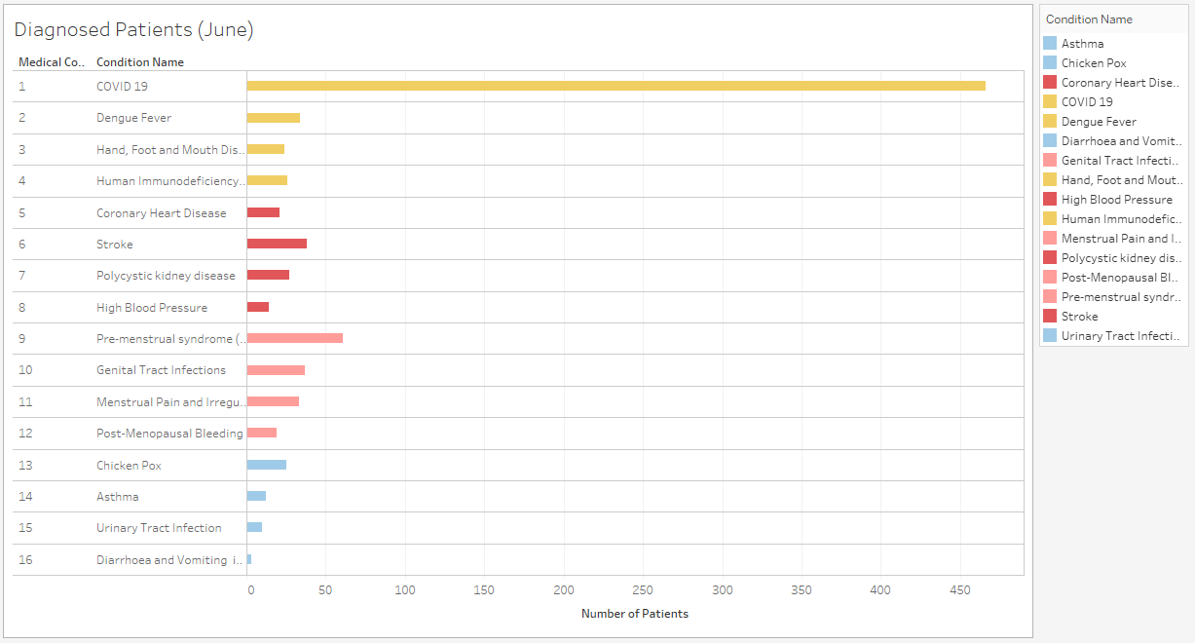

**[MITHIYRA]**

This graph indicates the high number of patients getting COVID-19 (first bar from the top, yellow colour) in the month of June. These numbers will only get higher, especially in the coming few months, as a vaccine is still not found. To accommodate the rising number of COVID-19 cases, more staff have to be shifted into the Infectious department, from the other 4 departments.

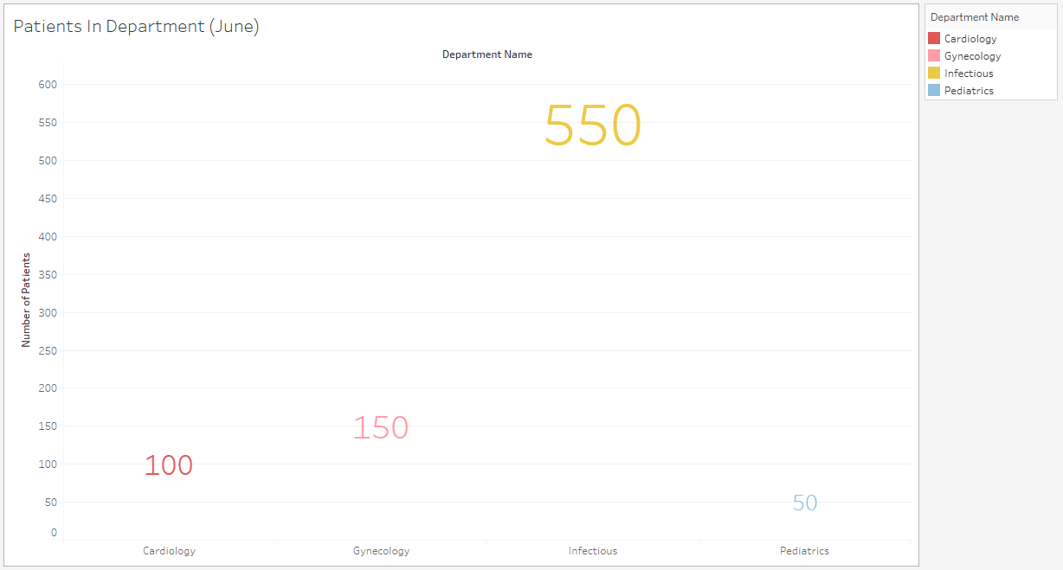

**[MITHIYRA]**

This graph indicates the large number of patients getting warded into the Infectious department (yellow colour), in the month of June. This further cements the fact that more staff should be allocated there due to the growing number of patients in the Infectious department, because of COVID-19 and dengue fever.

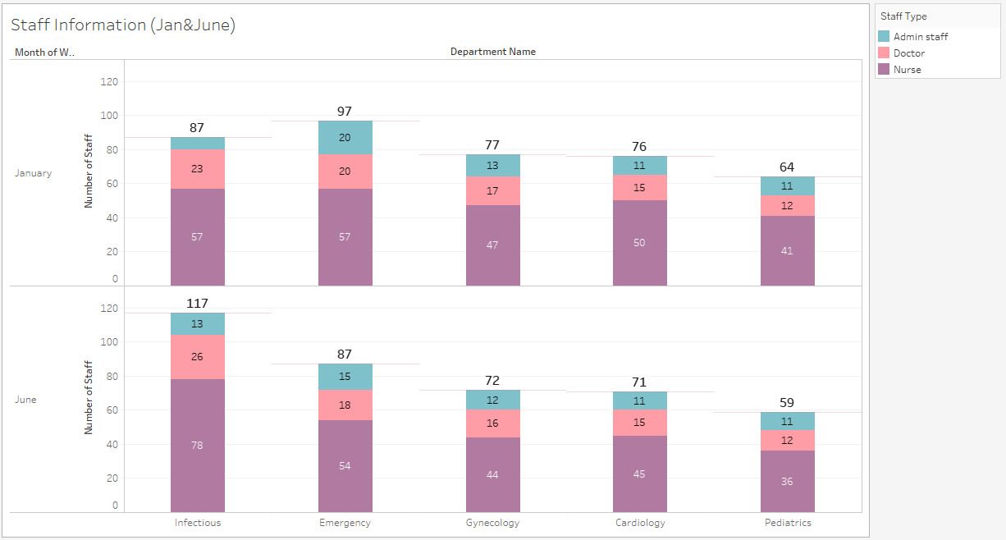

**[MITHIYRA]**

This graph compares the staff strength in each department in the months January and June. January is the month where there were little to no cases of COVID-19. June, on the other hand, has the most number of patients admitted into the hospital for COVID-19. Which is why the comparison between these 2 months is good, so that a clear difference is seen. A further staff breakdown is shown, according to staff type. Purple for nurse, pink for doctor and light blue for admin staff.

The hospital has successfully shifted more staff into the Infectious department to cater to the growing number of COVID-19 patients. There is an increase of 30 staff, from 87 to 117. The Infectious, Emergency, Cardiology and Pediatrics departments have fulfilled the international Doctor:Nurse ratio standard. Except for the Gynecology department, which shows that there are 2.75 nurses for every doctor, which can be improved. The solution can be that new staff coming into the hospital can be put into the Gynecology department so that the Doctor:Nurse ratio can be 1:3.

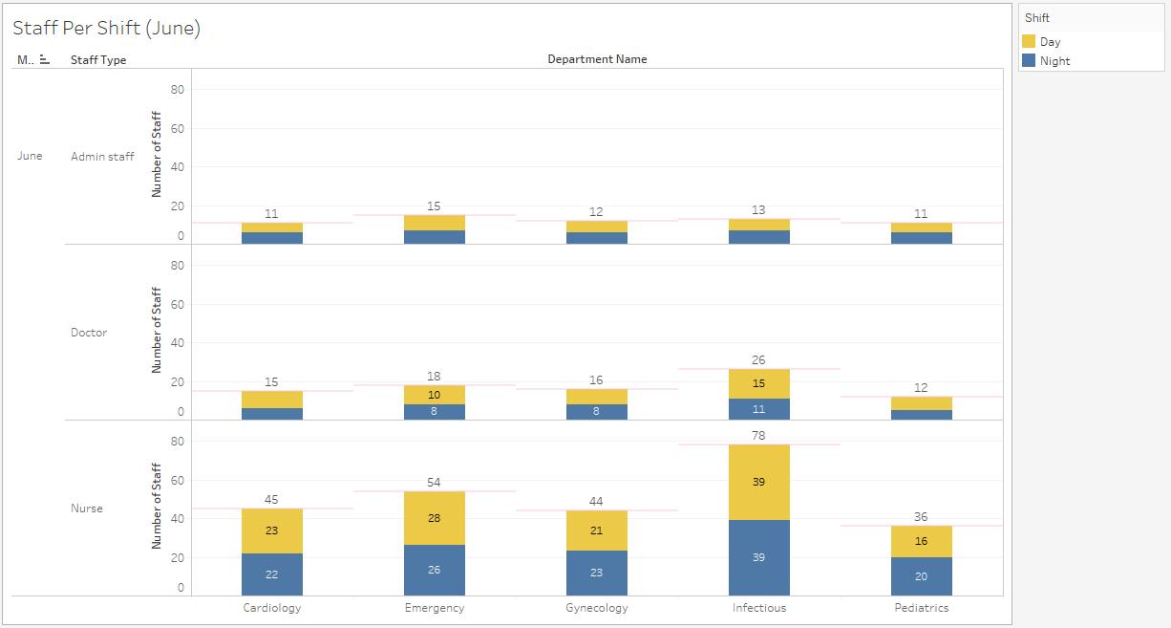**[MITHIYRA]**

This graph shows the distribution between staff in the Day and Night shift, in each department and the different staff types (in the month of June). The hospital’s goal should be that the staff, doctor, nurse or admin staff, in Day and NIght shifts should be balanced. Slight imbalance, like 1-3 staffs more in one shift than the other, is acceptable. Anything more is to be monitored closely and encouraged to balance out properly.

The difference between Day and Night is 4, for the nurses in the Pediatrics department and the doctors in the Infectious department. They will have to be balanced out by the new staff coming into the hospital or the staff already in the hospital.

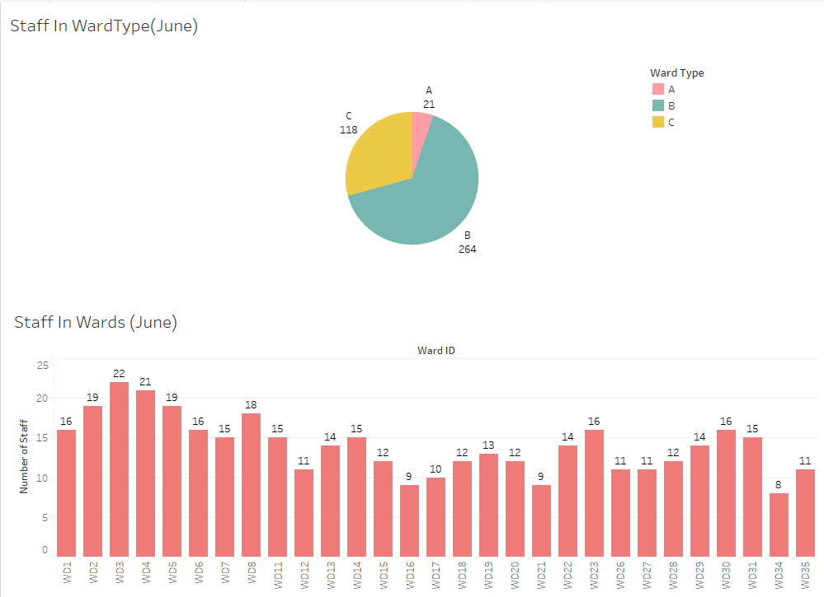

**[MITHIYRA]**

This dashboard contains 2 graphs, both centered in the month of June. The top is about the number of staff in ward types A, B and C. The bottom is about the number of staff in each ward, from WD1-WD35. From the top graph, it's seen that ward type B has the highest number of staff, indicating that more patients are warded there. Thus if more staff are hired it is better to place them in wards that are type B, since the demand for them among patients is high.

From the bottom graph, it is seen that WD9,10,24,25,32 and 33 cannot be found. This is because they are empty. These wards also happen to be ward type A. This shows that the demand is very low for type A wards during the pandemic period. So it is best if these wards are converted to type C to accommodate the rising number of COVID-19 patients. Converting of ward types also prevents the problem of overcrowding in wards that are already full.

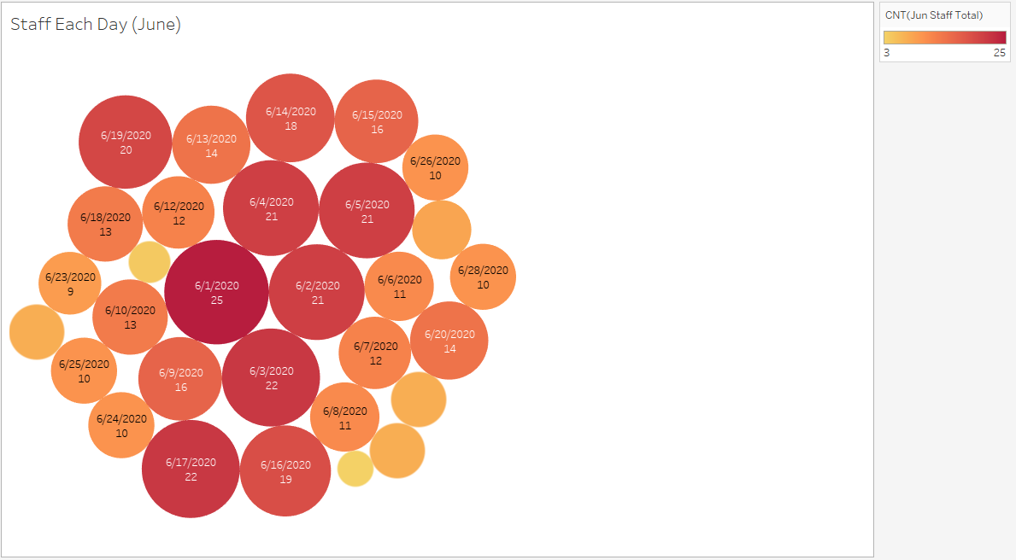

**[MITHIYRA]**

This graph shows the number of staff on duty everyday in the month of June.This graph will be useful for staff in charge of duty rosters. Those staff should be monitoring the amount of staff allocated everyday so that there isn’t an issue of understaffing. Days with less than 10 staff indicates the lack of planning when it comes to allocating them into different departments and wards. As seen above, there are 7 circles that indicate that there were less than 10 staff in a day. The hospital should plan allocation much better and aim for zero days with less than 10 staff.

**Learning Point/Conclusion[MITHIYRA]*:***

In conclusion, due to the growing number of COVID-19 patients, the hospital's focus is to strategically allocate their staff across the Day and Night shifts to aim for balance. And shift staff into the Infectious Department to cater to the growing number of patients. Caring for and treating patients is a hospital's number 1 priority. So, doctors, nurses and admin staff will have to be spread out across the shifts and departments properly to serve patients.

The hospital should also take the initiative to use the empty ward type A wards and convert them to ward type C wards. This is a step to prepare for the future as there will only be an increase in COVID-19 patients. Converting of wards will prevent overcrowding in wards that are already full. It will also enable the hospital to offer patients an affordable stay, due to the low price of ward type C wards.

Learning points were that I learnt Tableau from scratch and familiarized myself with Excel. Tableau is a programme that I have never used before. It was very educational since I was able to analyze data through graph making. I learnt that graphs help with looking at data in different perspectives. I was only familiar with bar graphs, pie charts and line graphs. But through Tableau I learnt to convey data in other types of graphs, like Packed Bubbles format, box-and-whiskers format and through different shapes. Familiarising with Excel was another learning point. I was able to organize my data through the given features. I learnt how to do calculations in Excel itself, without depending on a calculator.

**B. [PRIYA] How can we reduce overcrowding of patients at the hospital each day? (Patient Accommodation)**

***i) Finding out the most common diseases among Patients. 🡪 Common Diseases Dashboard* [PRIYA]**

Over the years since the United Hospital Centre (UHC) started in Singapore, patients were admitted for various medical conditions under departments such as Infectious, Cardiology, Gynaecology and Paediatrics. The objective of the findings is to find out the reasons as to why and what type of patients were admitted to UHC. Using a variety of visualisations (e.g. word cloud, back-to-back graph, bar graphs), the hospital board can now discover new insights.

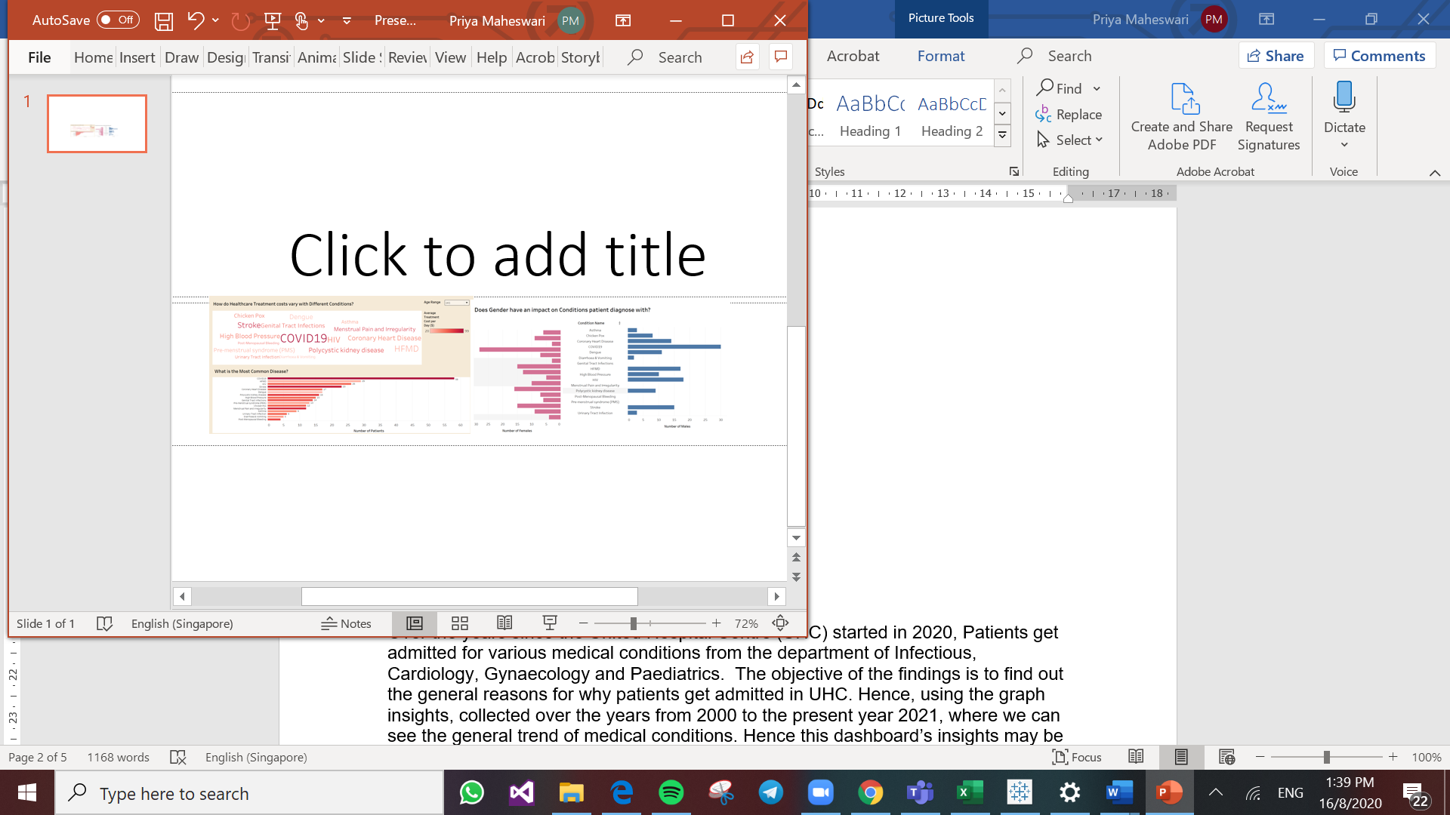

***Dataset Associated****:* PatientsRegistrations, Medical Condition.

**Graph 1: Common Diseases Word Cloud with Treatment Cost**

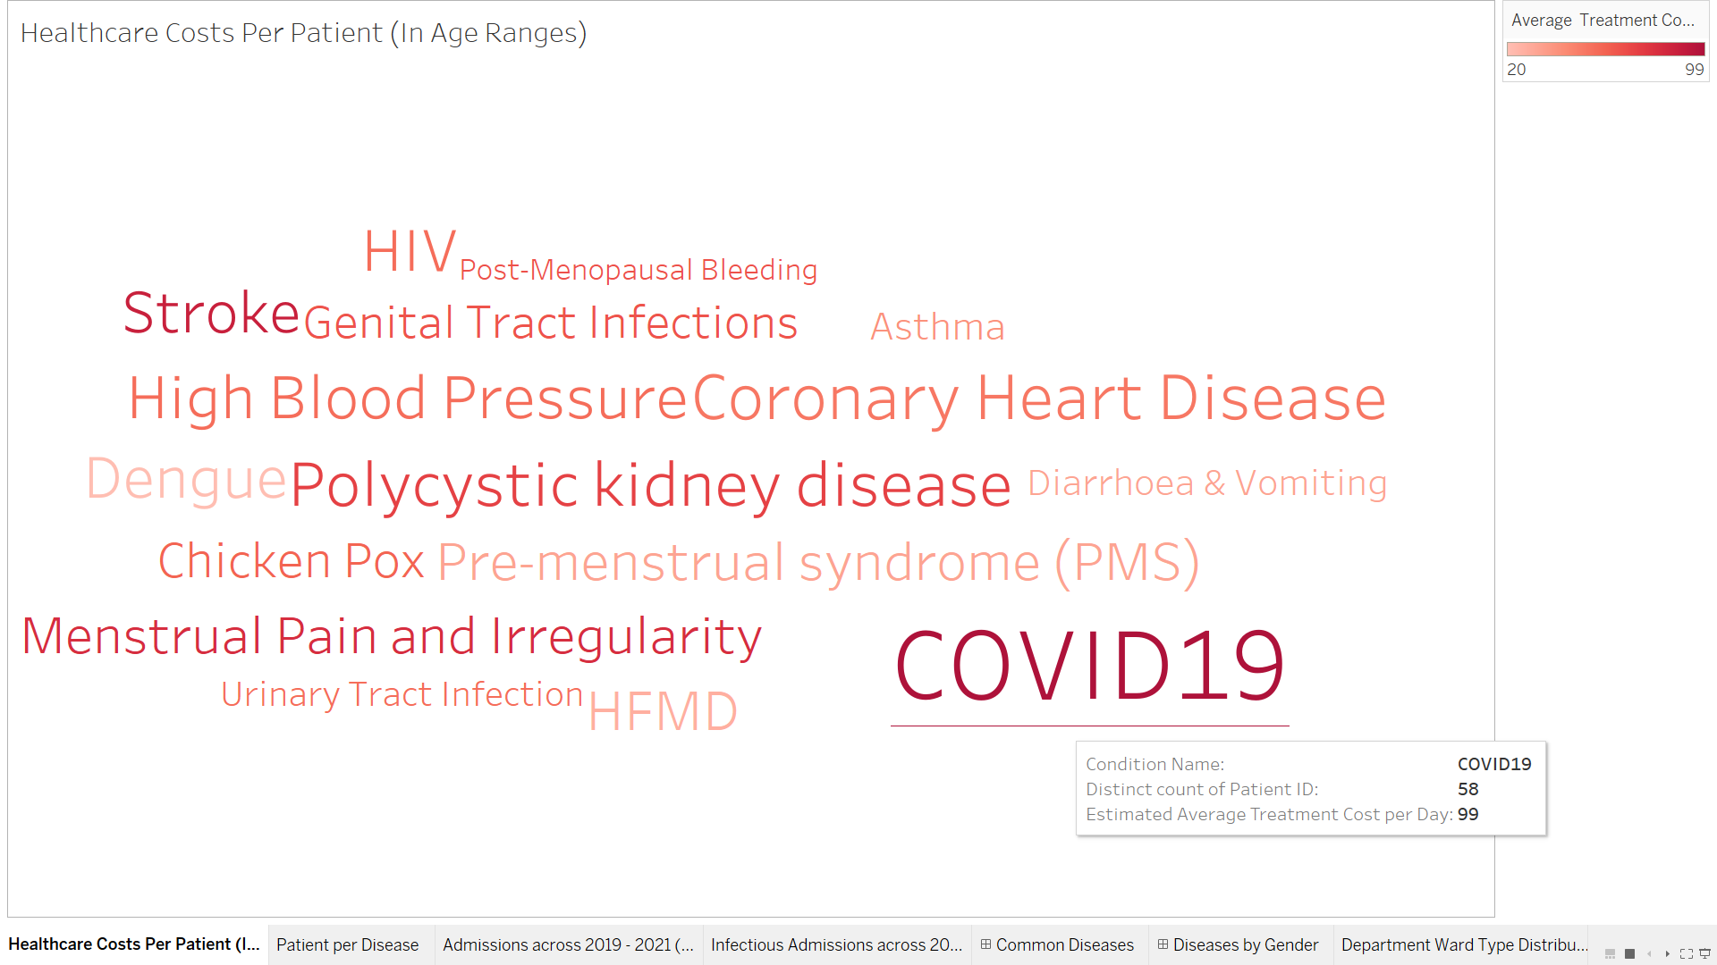

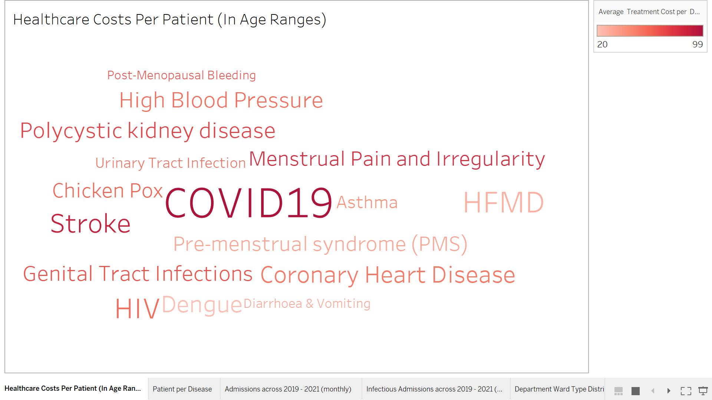  
  
The Common Disease Word Cloud, which is different from an ordinary list, acts as a weighted list visually representing the different medical conditions. The increasing number of patients admitted for a particular medical condition is depicted through the increasing font size, while the darkening of the red font colour depicts the increasing treatment cost.

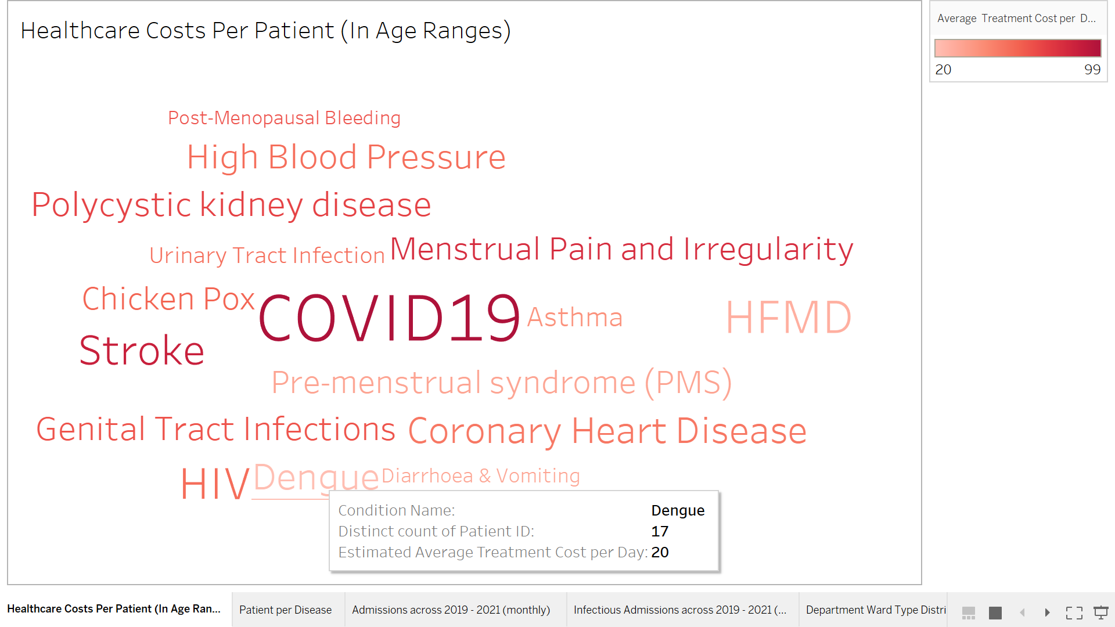

From the word cloud, we can easily infer two associations : -   
1) COVID-19 has the highest number of patients, while Post-Menopausal Bleeding has the lowest number of patients.  
2) COVID-19 has the most expensive treatment cost of $99 per day, in the darkest shade, while Dengue costs the least of $20 per day, in the lightest shade.

The reason why I used a word graph is because it is visually appealing and eye-catching to the viewers eyes. Also, just in one look you can find out not only the most or least common diseases but also the highest or lowest treatment costs.

**Graph 2: Bar Graph of Common Diseases with the Treatment Cost [PRIYA]**

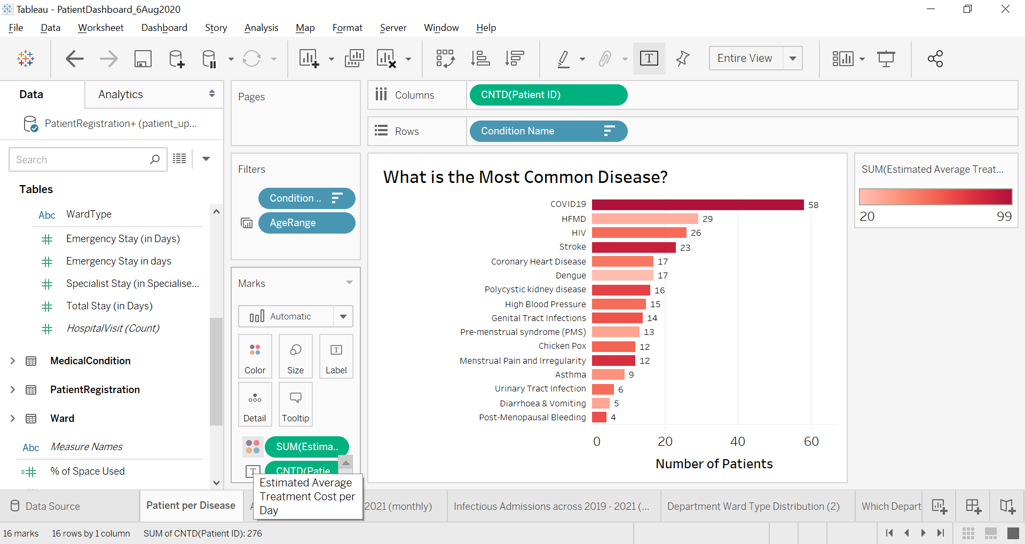

As an extension of the word cloud, the bar graph helps to further reinforce the objective of conveying the most/least common diseases patients diagnosed. With the aid of this bar graph, sorted in descending order according to patient count, it is clearly visible which is the most and least popular disease. Hence the most diagnosed disease is placed on top (58 patients) while the least diagnosed disease is placed at the bottom (4 patients).

**Data Exploration: Different Age Ranges**

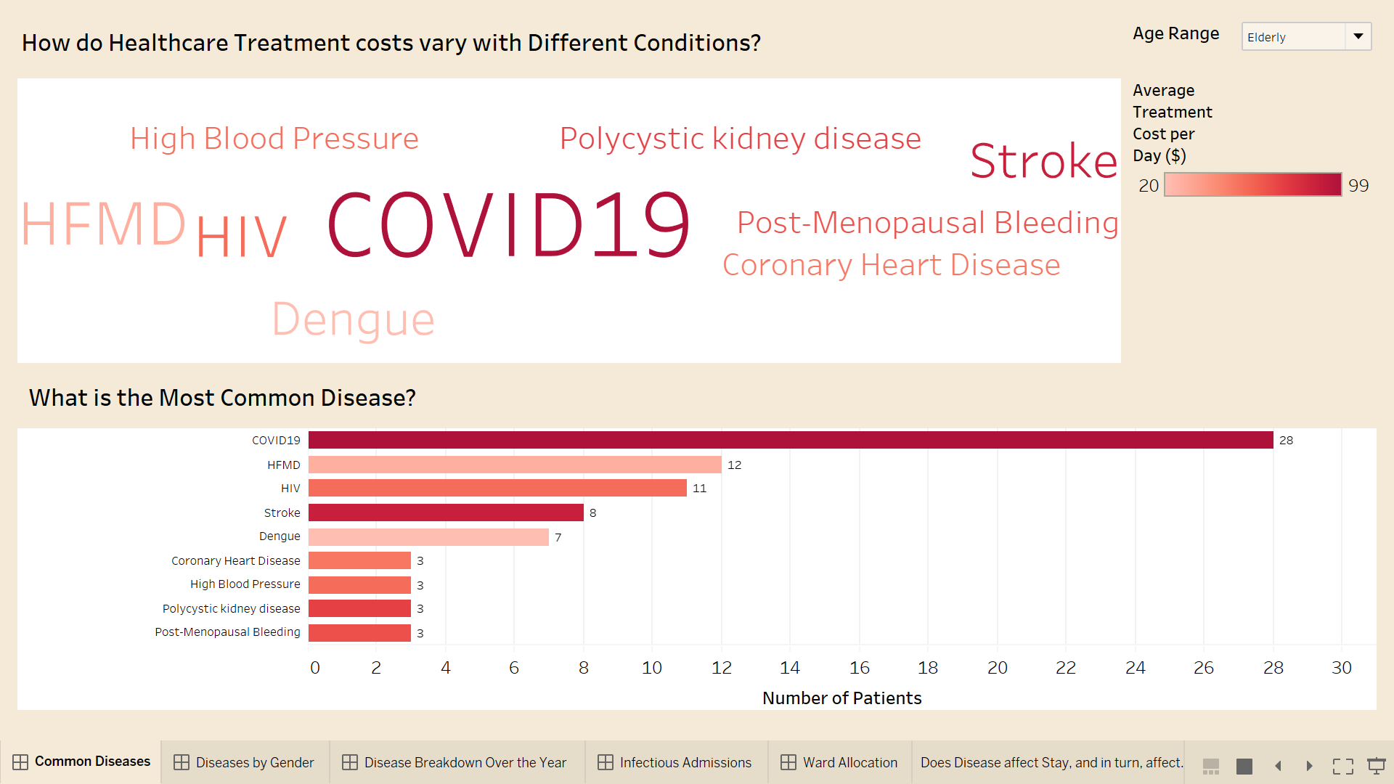

In this Dashboard itself, I have also added a filter on the top left of the dashboard called Age Range where users can filter the patients according to their age, named Adults, Children and Elderly. Hence with the aid of this filter we can gain insights whether the age of the patients have an effect on the type of diseases they can be diagnosed with.



For example, if I apply the ‘Elderly Age range’ filter to the dashboard, we can infer that elderly usually can be infected with 9 common diseases, where elderly highly get infected with COVID-19, with 28 of them . This means about half of COVID-19 patients (total 58) are actually elderly. And also we can infer that it is usually female elderly who get diagnosed with Post-Menopausal Bleeding with 3 patients, where this disease is usually associated with older age nature.

Hence from the Age range Filter, we can conclude that The COVID-19 pandemic is impacting the global population and Singapore population in drastic ways. Also research has found that the older people are facing the most threats and challenges at this time, as compared to Children or adults. Although all age groups are at risk of contracting COVID-19, the older people, especially those with pre-existing medical conditions are more vulnerable to becoming severely ill with the virus. This can be due to physiological changes that come with aging and potential underlying health conditions.

**Graph 3: Back-to-back Bar Graph of Gender having impact on conditions patients diagnose with. [PRIYA]**

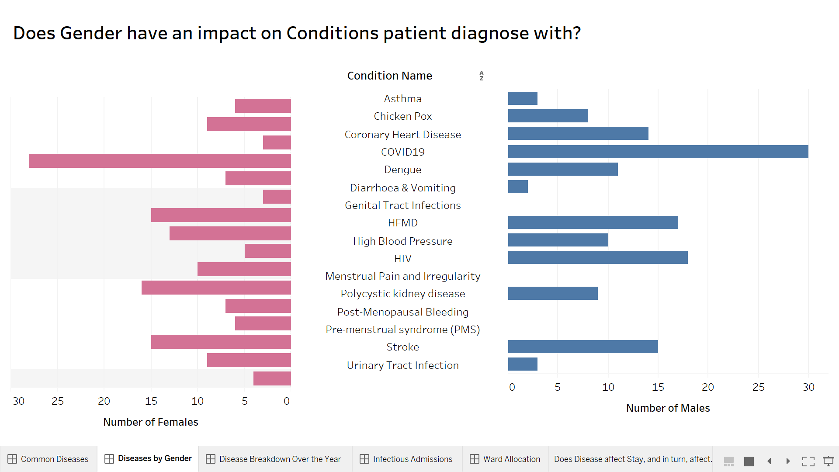

In this graph, you will be able to gain insights on the graph with regards to how the genders have the impact on the disease patients get diagnosed with. Hence the graphs on the left are representing the diseases Female patients get diagnosed with while in the right it represents the male conterpartners. This type of graph helps in finding the insights based on the comparison between the Males and Female patients, as it visually displays the comparison.

For example in our hospital, we have a department called Gynecology, where it is only catered to female patients with female reproductive system problems. Hence, it is logical to say that Male patients will not get diagnosed with gynaecological diseases. Hence based on the graph it is evidence there are zero male patients (indicated in blue colour) who are diagnosed with gynaecological diseases like Genital Tract Infections.

**Conclusion and Recommendation for dashboard [PRIYA]:**

As such we can ensure that all patients get bed accommodations and well treatments and services for them to recover faster. In conclusions, this dashboard’s insights may be helpful in the future planning process of allocating patients according to their requirements and medical conditions.

In conclusion, this dashboard’s insights may be helpful in the future planning process of allocating patients according to their requirements and medical conditions, to ensure that all patients get adequate treatments and services. Also, we can will be analyse other insights like the Average Treatment cost per Day ($) for the respective medical conditions, relationship between Patient’s age and the medical condition they are diagnosed with and see the relationship between the patient’s gender and the medical conditions that they get admitted for.

In conclusion, we can conclude that over the years, COVID-19 has the highest number of patients admitted with 58 patients and it is also the most expensive treatment cost average of $99 per day. Also, we can conclude that age and gender do have an impact on the type of diseases that patients get diagnosed with. In general, the elderlies are more prone to get infectious diseases like COVID-19 their physiological changes that come with ageing and potential underlying health conditions, where they are known to have weaker immune systems to fight against this virus.

***ii) Finding out the Disease breakdown over the years 2019-2021* [PRIYA]**

Daily, patients admitted into the hospitals for various medical conditions from different departments.  However, after Singapore got its 1st reported COVID-19 case on 23 January 2020, there is a huge rising number of patients’ cases related to COVID-19 and even other infectious diseases. Hence it is important to analyse the specific disease for which patients get admitted for on a typical monthly basis and which departments the diseases from. Hence the objective of the findings, is to closely monitor admissions of patients and their reason for admission from January 2019 to December 2021.

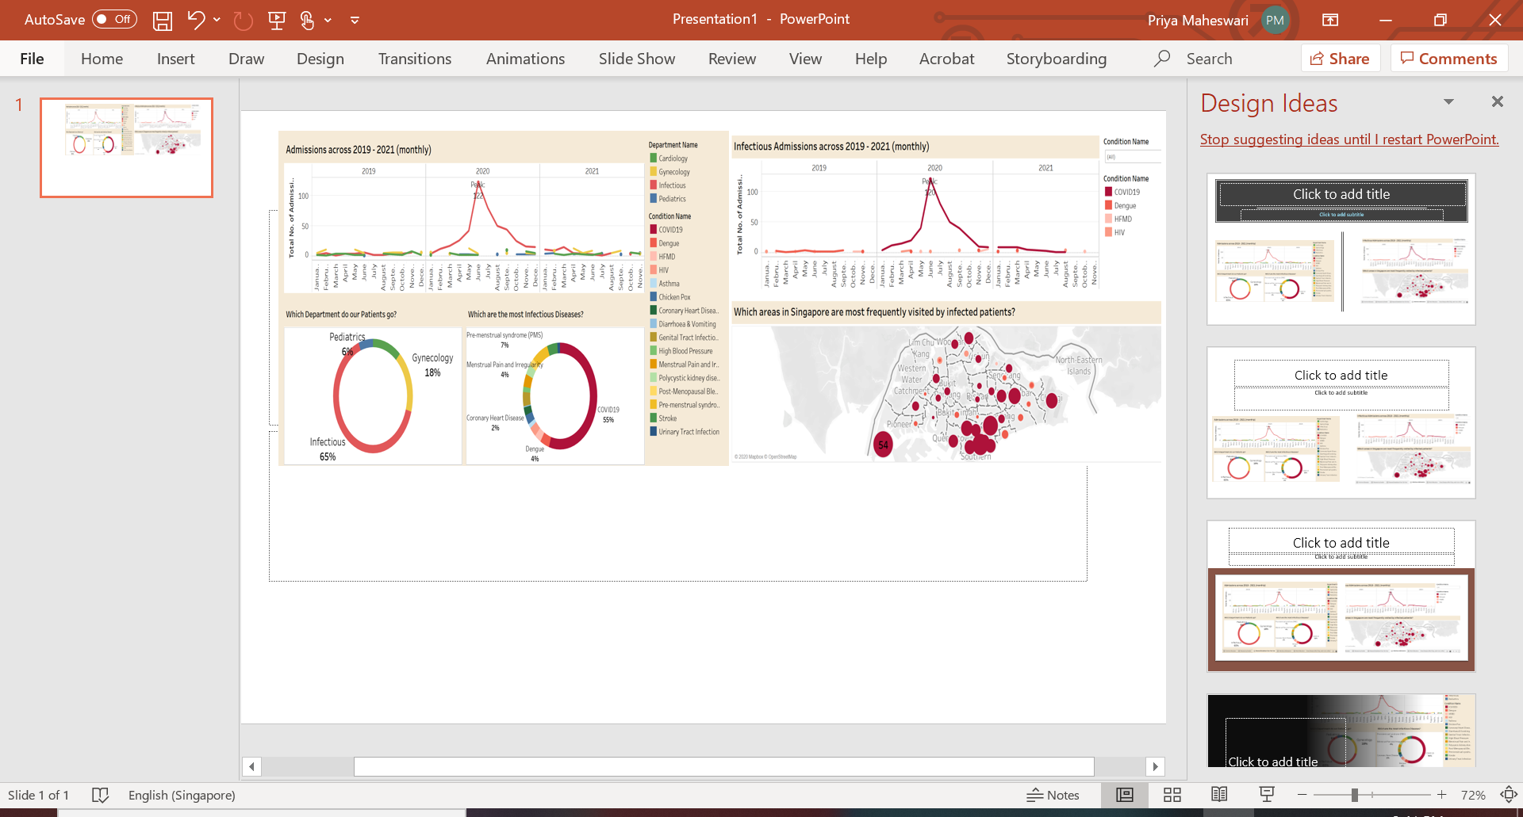

**Dataset Associated:** PatientRegistration, HospitalVisit, Department, Ward, Medical Condition

**Graph 1: Line Trend Graph associated with Hospital Admission across 2019-2021 [PRIYA]**

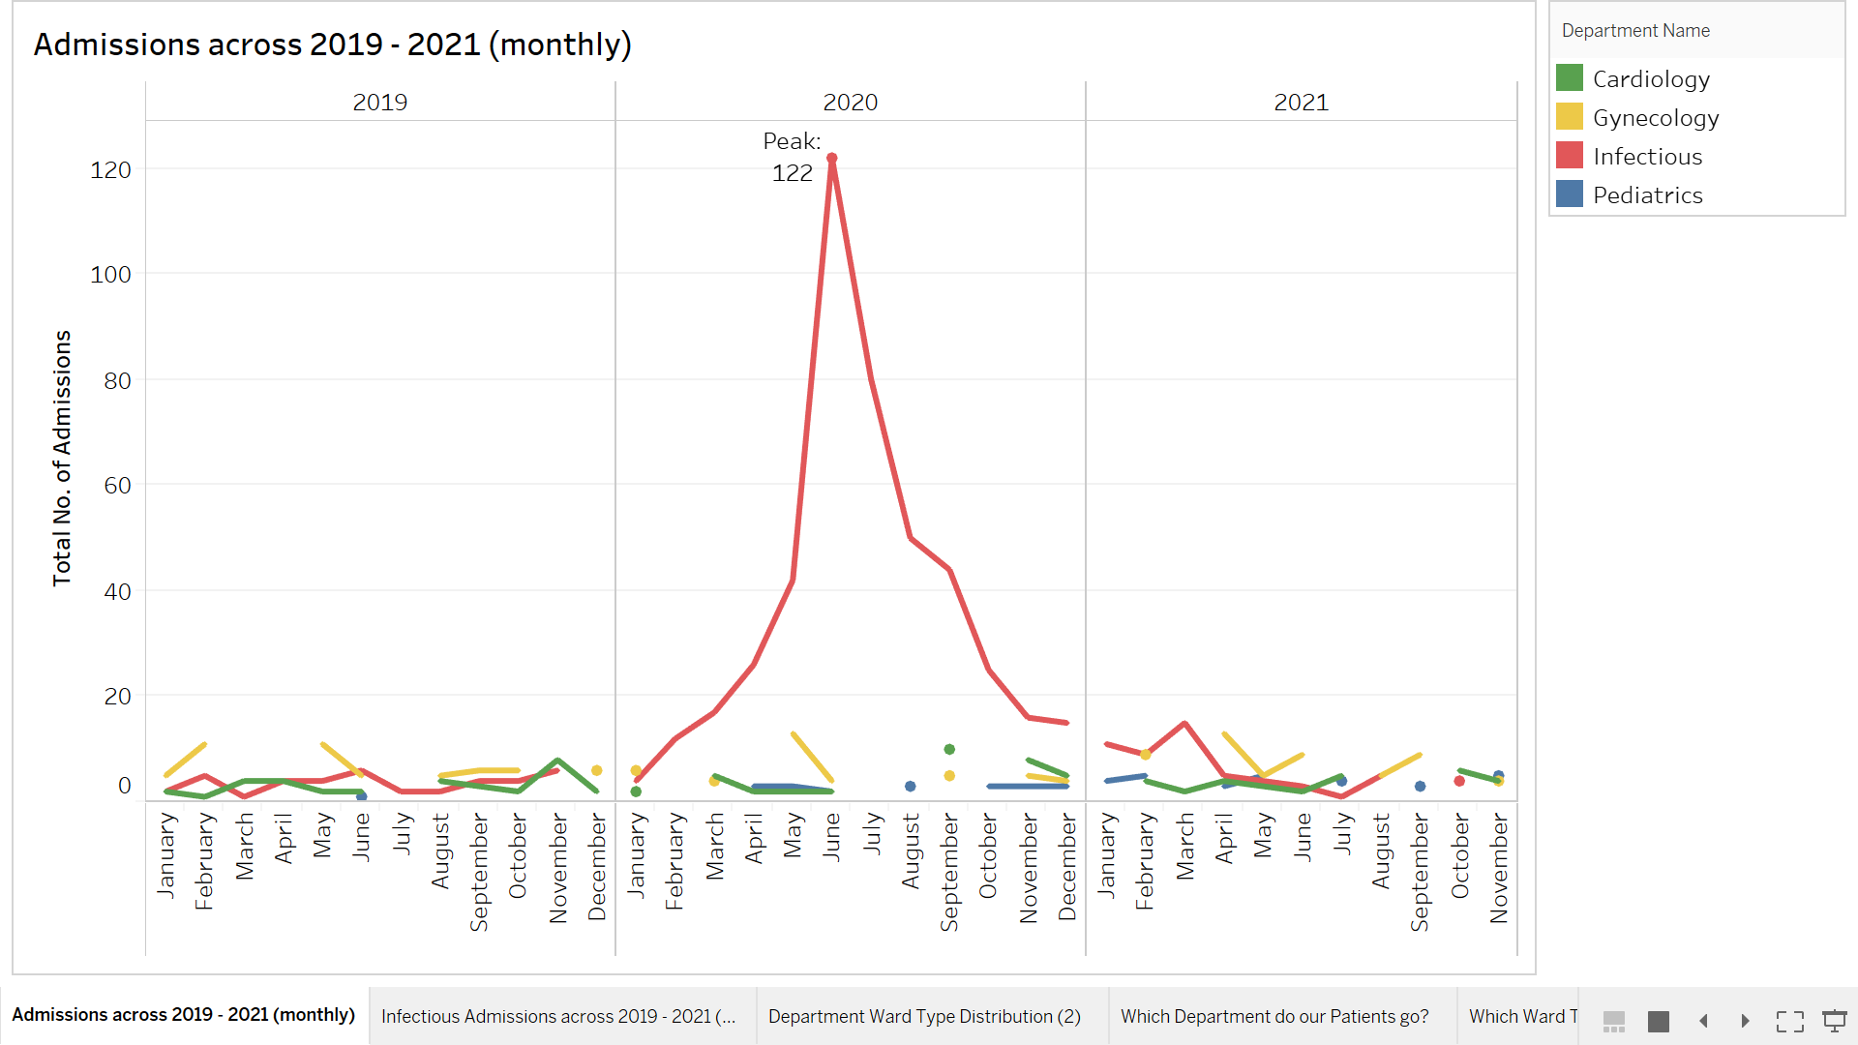

I have implemented a line trend graph to see the overall trend in the patients’ admissions from January 2019 till December 2021. However, the number of admissions is accumulated represented in terms of 4 department as shown in the legends above

Also, in this graph, you can visually see the total number of admissions for every 36 months from 2019- 2021. I have used line graphs as it can give a quick analysis of data. You’re able to quickly tell the minimum/maximum, as well as if there are any gaps or clusters. This means that it can easily observe trends/patterns over the 3 years.

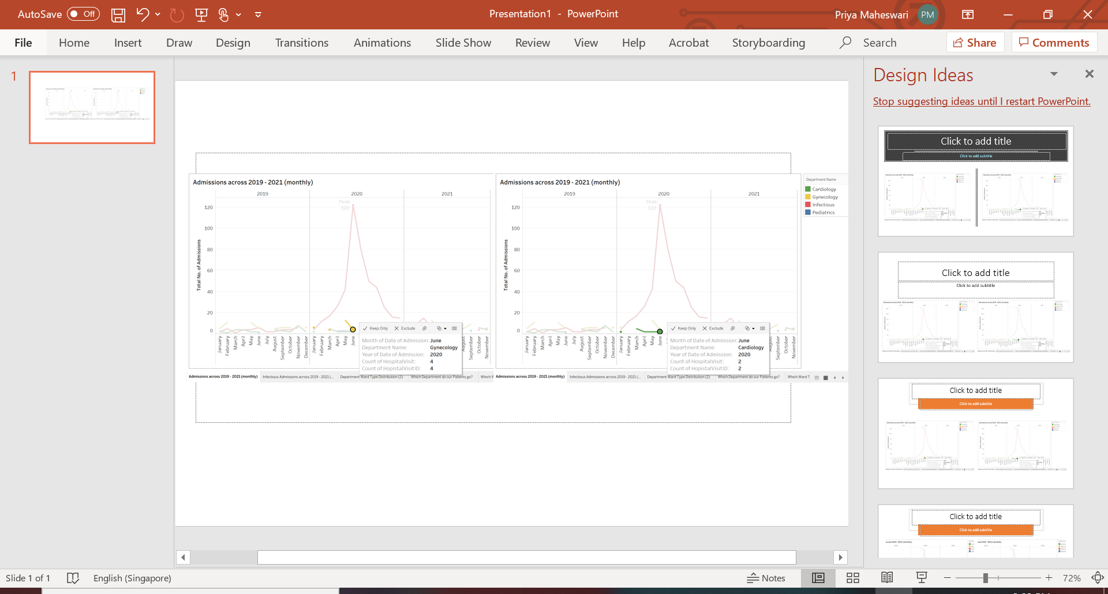

For example, in the graph above, you can infer that in the month of June 2021, the Infectious department has the highest number of cluster peaks of 122 admissions just from the Infectious Department. However, in the same month of June 2021, there are only 4 and 2 patients admitted into the Gynaecology and Cardiology Department respectively, indicating that there are possibilities of having a huge margin of COVID-19 patients admitting. It is because in the year of 2019, Infectious departments , had low number of admissions in Infectious departments(indicated in red line), while there is huge sparks of admissions from January 2020 till June 2020 in the infections Department, We can also comprehend that is a huge spark as COVID-19 was introduced to Singapore in 23 January 2020.

Therefore, we can infer that in the year 2020, especially in the middle of the year, there many patients will lack, bed accommodations, due to the overwhelming admissions from the Infectious Department

**Graph 2 & 3: Donut Graph of Representing which Department do our Patients usually go to and the most infectious diseases[PRIYA]**

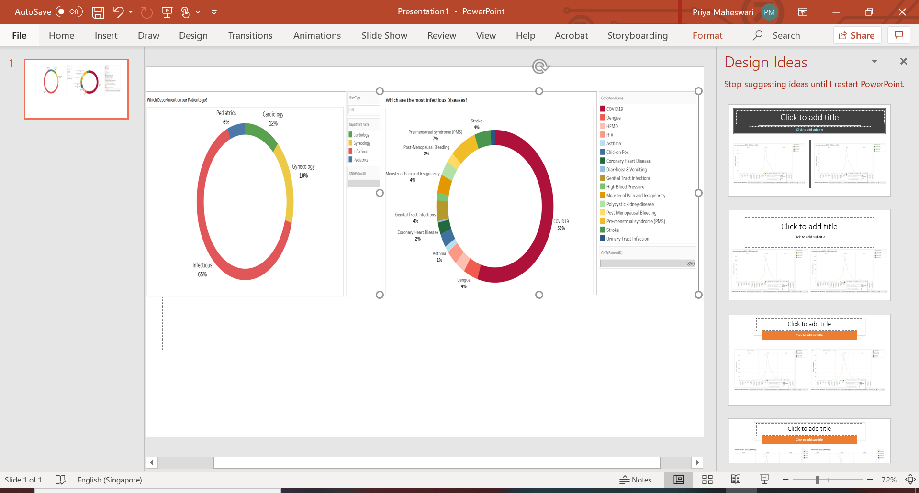

In graph 2, it shows an overall representation of which department do patients get admitted in across year 2019-2021. In graph 3, it shows which diseases patients usually get diagnosed with across the year 2019-2021.

The reason why I used a donut graph is because readers can focus more on reading the length of the arcs, rather than comparing the proportions between the slices. Also, donut charts are more space-efficient than Pie Charts because the blank space inside Donut Chart can be used to display information inside

At the same time, I have given colour-coordination for the graphs between the department and the diseases in that department. For example, The Infectious departments are labelled in red colour. Hence the diseases in the Infectious Departments, named COVID-19, Dengue, HFMD and HIV are also labelled in the different shades of Red. Hence it would be easier for user to Interpret Graph 3, as they will know which diseases belongs to which department based on the colour assigned to the donut sector

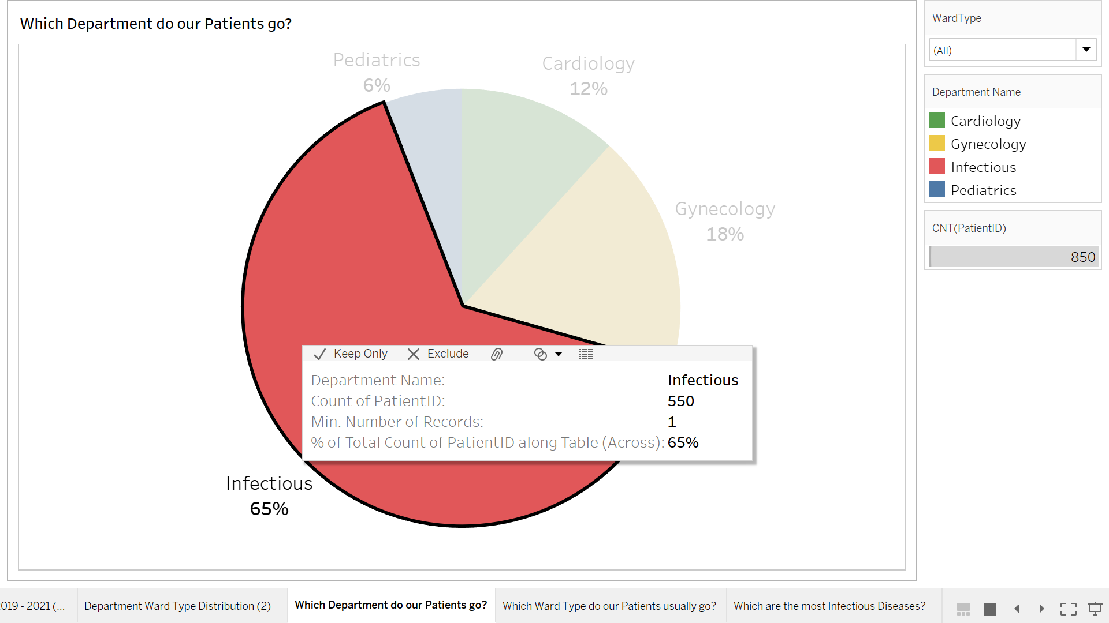

For example, If I hover on the Infectious Department of Graph 2, we can infer that Infectious Department has the highest number of Admissions of 550 records as compared to other departments

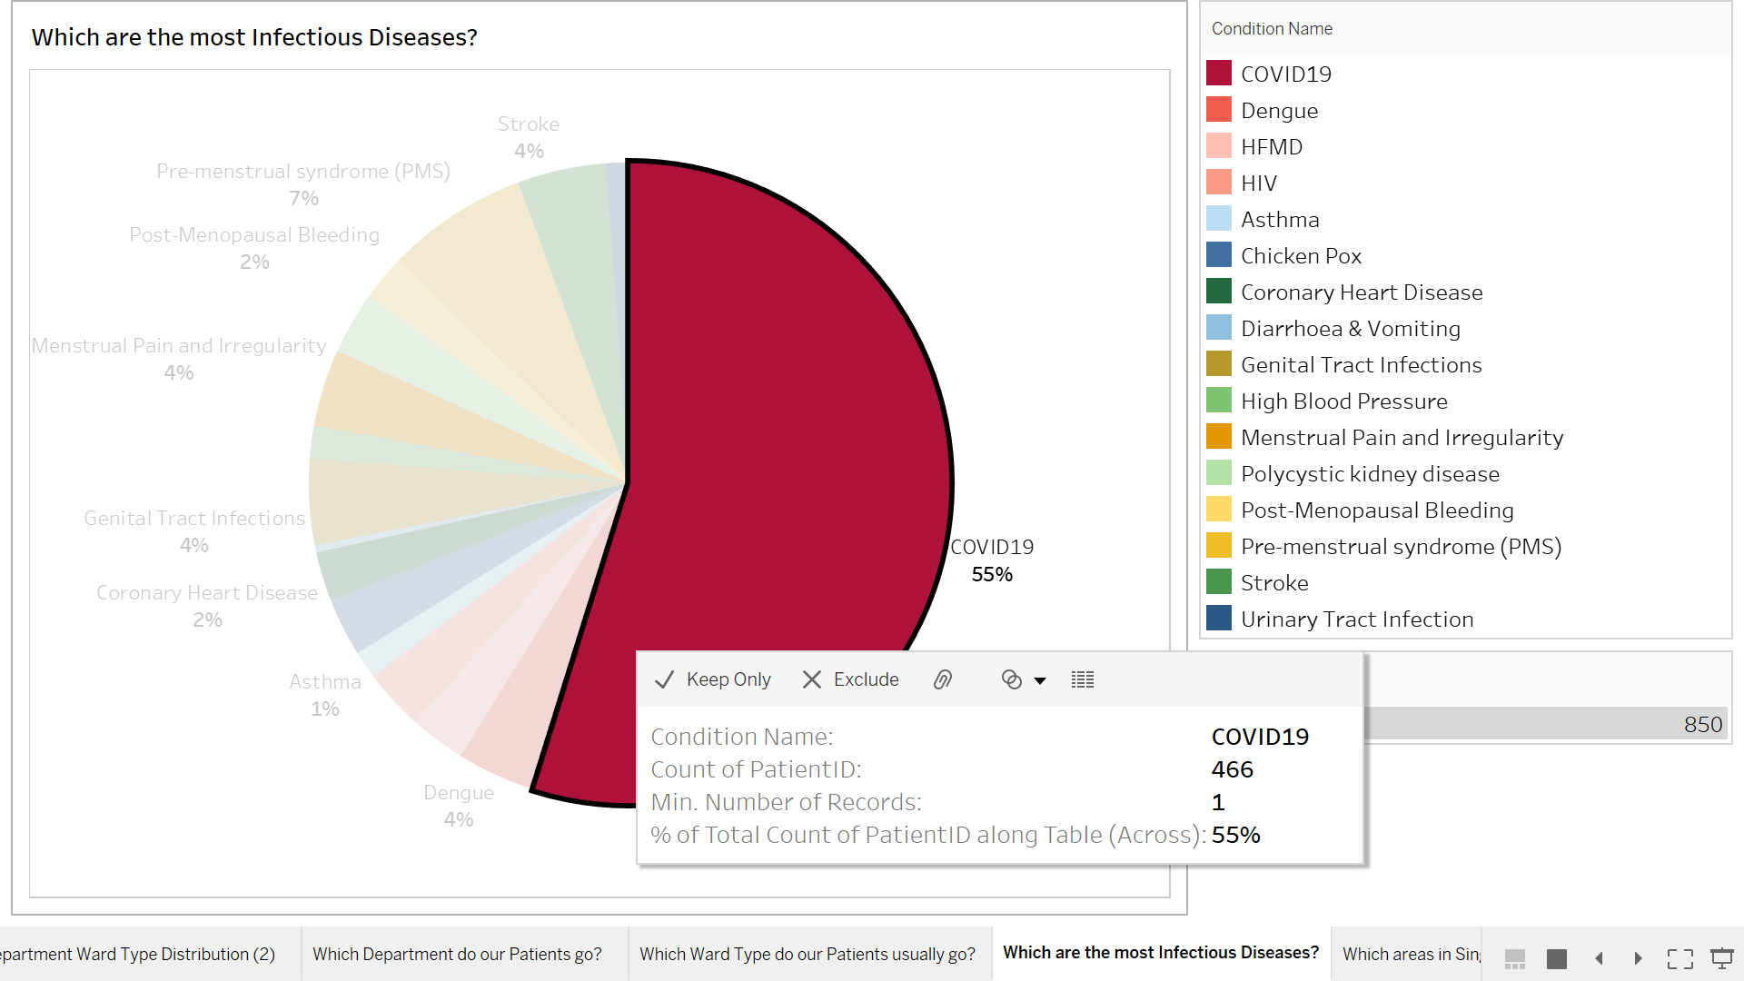

As we know, the Infectious Department consists of diseases like COVID-19, Dengue, HFMD and HIV. Hence in the graph3, we can infer that COVID 19 has the highest number of admissions of records of 466. This means that we can interpret that COVID-19 is the main contributor to the Infectious Department, causing it to have the highest number of patients admitted.

Therefore, we can infer that in the year 2020, especially in the middle of the year, there many patients will lack bed accommodations, due to the overwhelming admissions from the COVID-19 virus.

**Special Feature: Month/Year Filter**

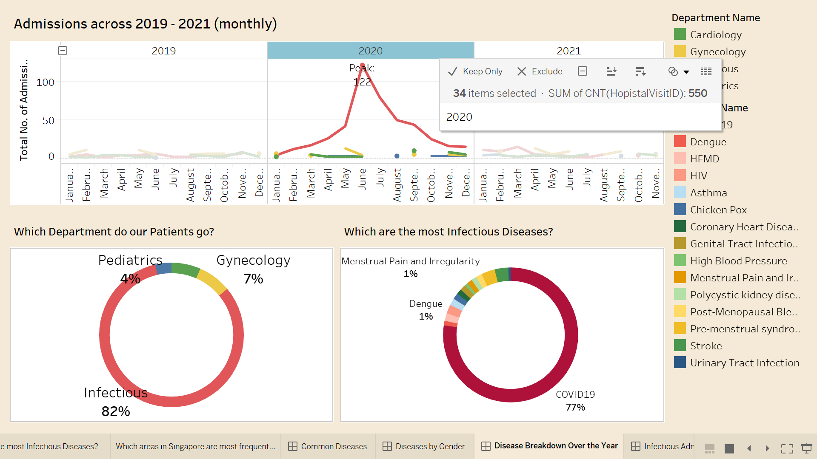

I also have a month/year feature where you can click on a particular month or a year, the graph will filter to show the data according to the filter applied. For example, if I click on the year 2020 filter, it only shows all the graphs related to 2020 for the line graphs and the donut graphs. Hence it is very visible that 2020 has the highest number of patients admitted to the Infectious department as the majority of the patients are diagnosed with COVID-19.

**Graph 4: Line Trend Graph associated with Infectious disease Admission across 2019-2021 [PRIYA]**

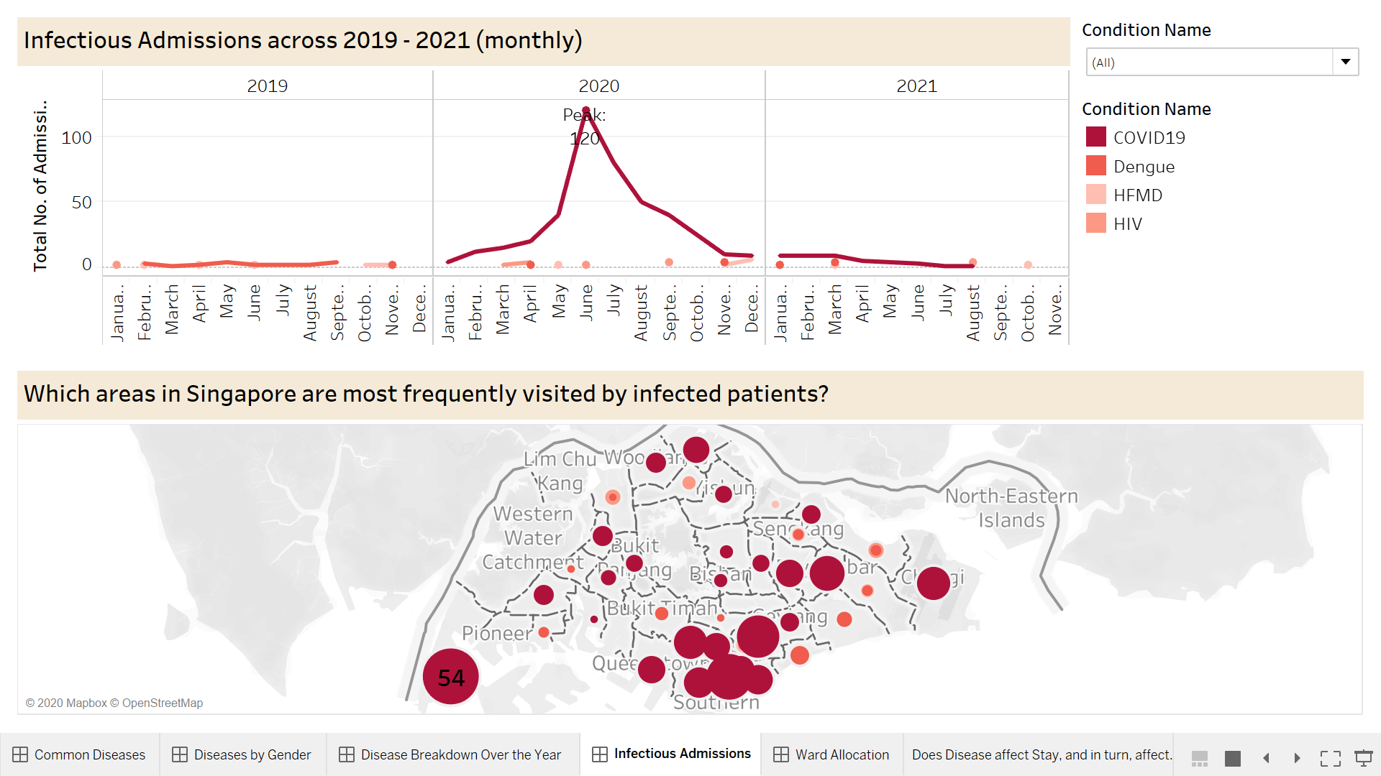

Based on the last 3 graphs, we can infer that the Infectious department has the highest number of admissions across 2019-2021. Hence, I decided to focus on creating graphical insights based on the Infectious Departments. The diseases are COVID-19, Dengue, HFMD and HIV. Hence this a graph

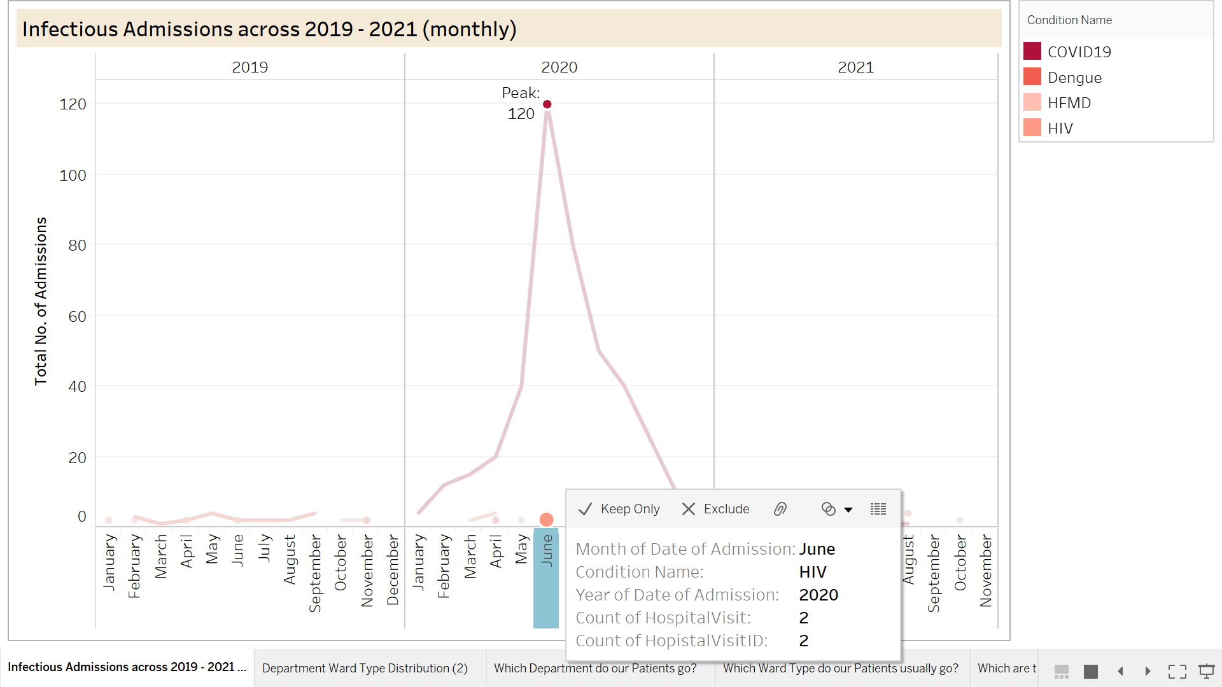

For example, in the graph above, you can infer that in the month of June 2021, it has the highest number of patient’s admissions cluster peak of 120 admissions just from the COVID-19 disease (in the darkest red shade). However, in the same month of June 2021, there are only 2 patients admitted into HIV diseases (indicated in the light orange shade). It is because in the year of 2019, COVID-19 have zero admissions I the 2019 while there is a sudden huge spark of COVID-19 admission from January 2020 till June 2020 in the infections Department,

We can also comprehend that it is a huge spark as COVID-19 was introduced to Singapore on 23 January 2020. Therefore, we can infer that in the year 2020, especially in the middle of the year, there many patients will lack, bed accommodations, due to the overwhelming admissions from the COVID-19 infectious disease

However from June 2020 onwards, we can notice that the number of COVID-19 admission has decreased. Hence from this we can conclude that Around June 2020, COVID vaccine has been found and those more patients are recovered from COVID-19. Also, in 2021, we can see that COVID-19 has drastically dropped. As such, there will be lesser issues with regards to patients overcrowding in hospitals or lack of accommodation of patients in the year 2021. At the same time, we can also conclude that in the year of 2021, people have become more health-conscious due to the breakout of the COVID-19 Pandemic. Hence people might have taken their health seriously by eating healthily, engaging in exercising or they might be introduced to our Health Programs and Schemes.

**Graph 5: Custom Geocoding graph representing which areas In Singapore has been frequently visited by Infectious Patients (Mainly COVID-19) [PRIYA]**

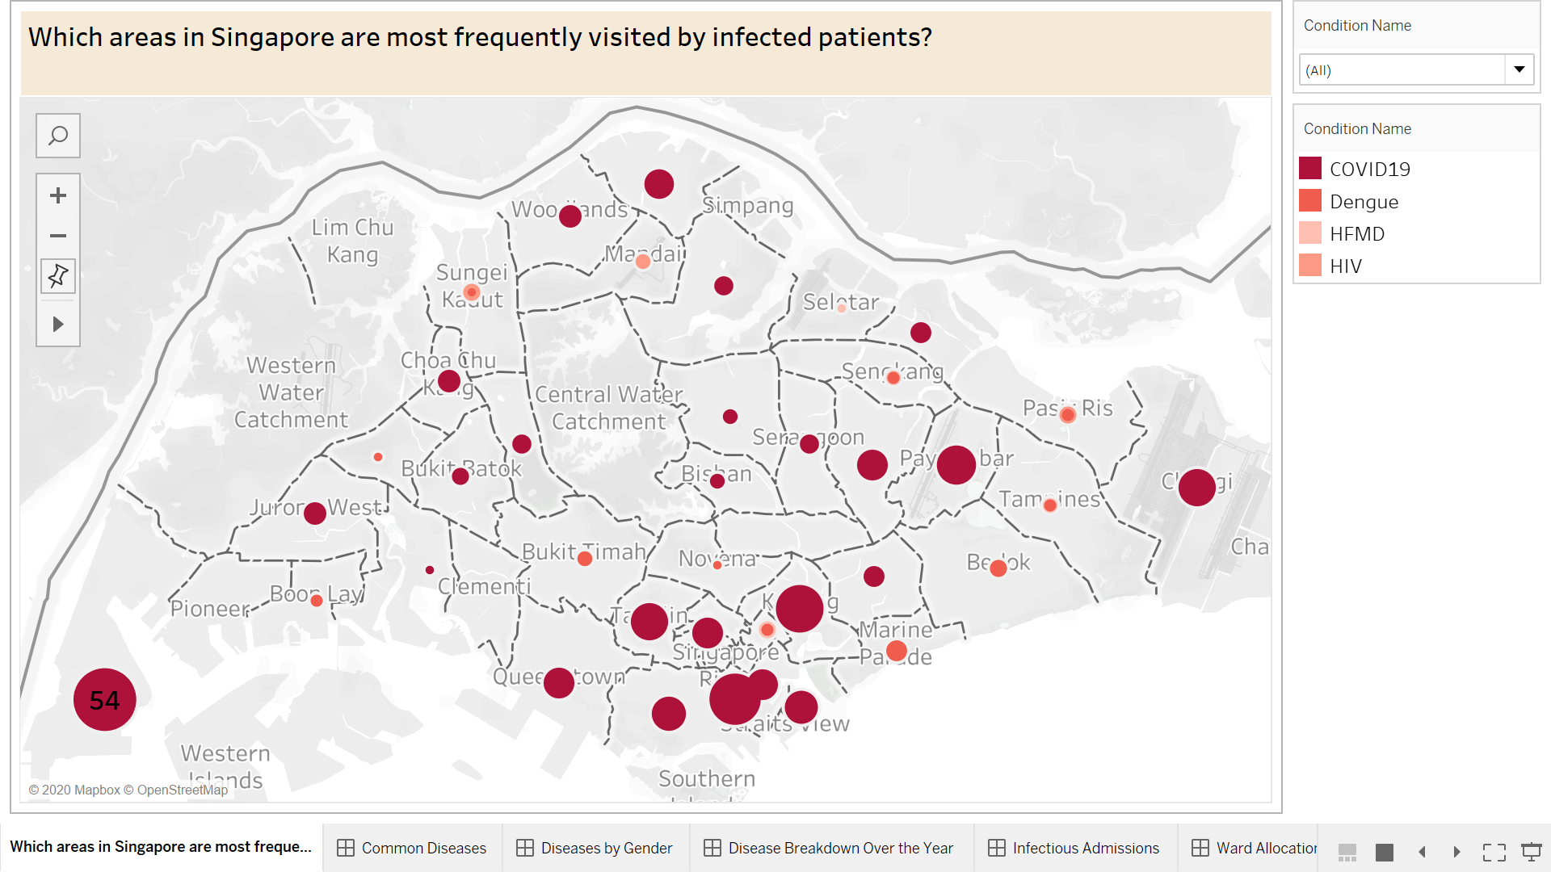

Based on the last 3 graphs, we can infer that the Infectious department has the highest number of admissions across 2019-2021. Hence, I decided to focus on getting graphical insights based on the Infectious Departments. The diseases are COVID-19, Dengue, HFMD and HIV. Hence, I have created a graph, which uses Geocoding tactics to infer which has been frequently visited Infectious Patients across Singapore.

Geocoding API is the process of where it converts addresses into spatial data and associates the exact geographical coordinates for the address. It is used in geographical information systems to help find coordinates of a place in Singapore where Infectious persons were seen at often. Hence it aids in recognising patterns within the information. With the aid of the map displaying the spread of COVID-19 over time, at quick glances , the map provides an interactive visual overview of the latest situation.

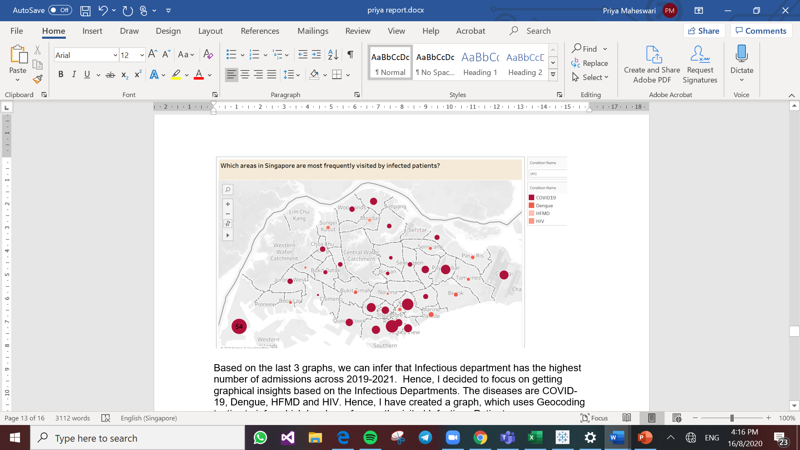

On the top right corner of the graph, you can see that I have added a filter feature, where users can use the filter to just get insights on a specific infectious disease itself (eg: COVID-19).

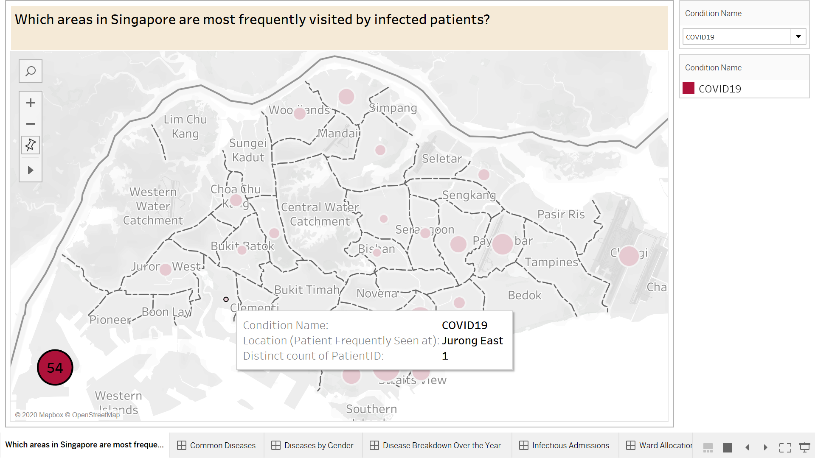

For example, I have selected to use the filter to only see insights on the COVID-19 diseases. As you can see the highest number of patients’ clusters were frequently seen in the Tuas Area of Singapore, while the least number of COVID-19 patients were seen in the Jurong East Area.

Hence this Geocoded graph can not only be helpful for the hospital, but for the government as well. It is because, COVID- 19 virus can be easily spread to another person, when there is contact between people. Hence both the Hospital and government can use this geocoded data from citizens’ mobile phone to perform “contact tracing’. The Contact Tracing method uses trajectory and geo-location data from mobile phones to detect and isolate individuals who were near someone who has been tested positive for COVID-19. Also, the governments can use this insight to release news to the public, to alert people of where COVID-19 Cluster was last seen as at. As such general public can be aware and be more mindful of not visiting those infection-prone areas (eg: Tuas)

The Singapore’s Government Technology Agency has developed an app called TraceTogether, which enables infected individuals to share information to share information with the authorities about those who they have come in contact with, thus we can do a swab test on the suspected and vulnerable people, to check if they have contacted COVID-19. Thus, can treat future patients as soon as possible and reduce the spread of infectious diseases. For example, since there is a large number of current patients seen in the Tuas Area, we can ensure that we do swab testing for people living in the Tuas area.

**Special Feature: Month/Year Filter:** 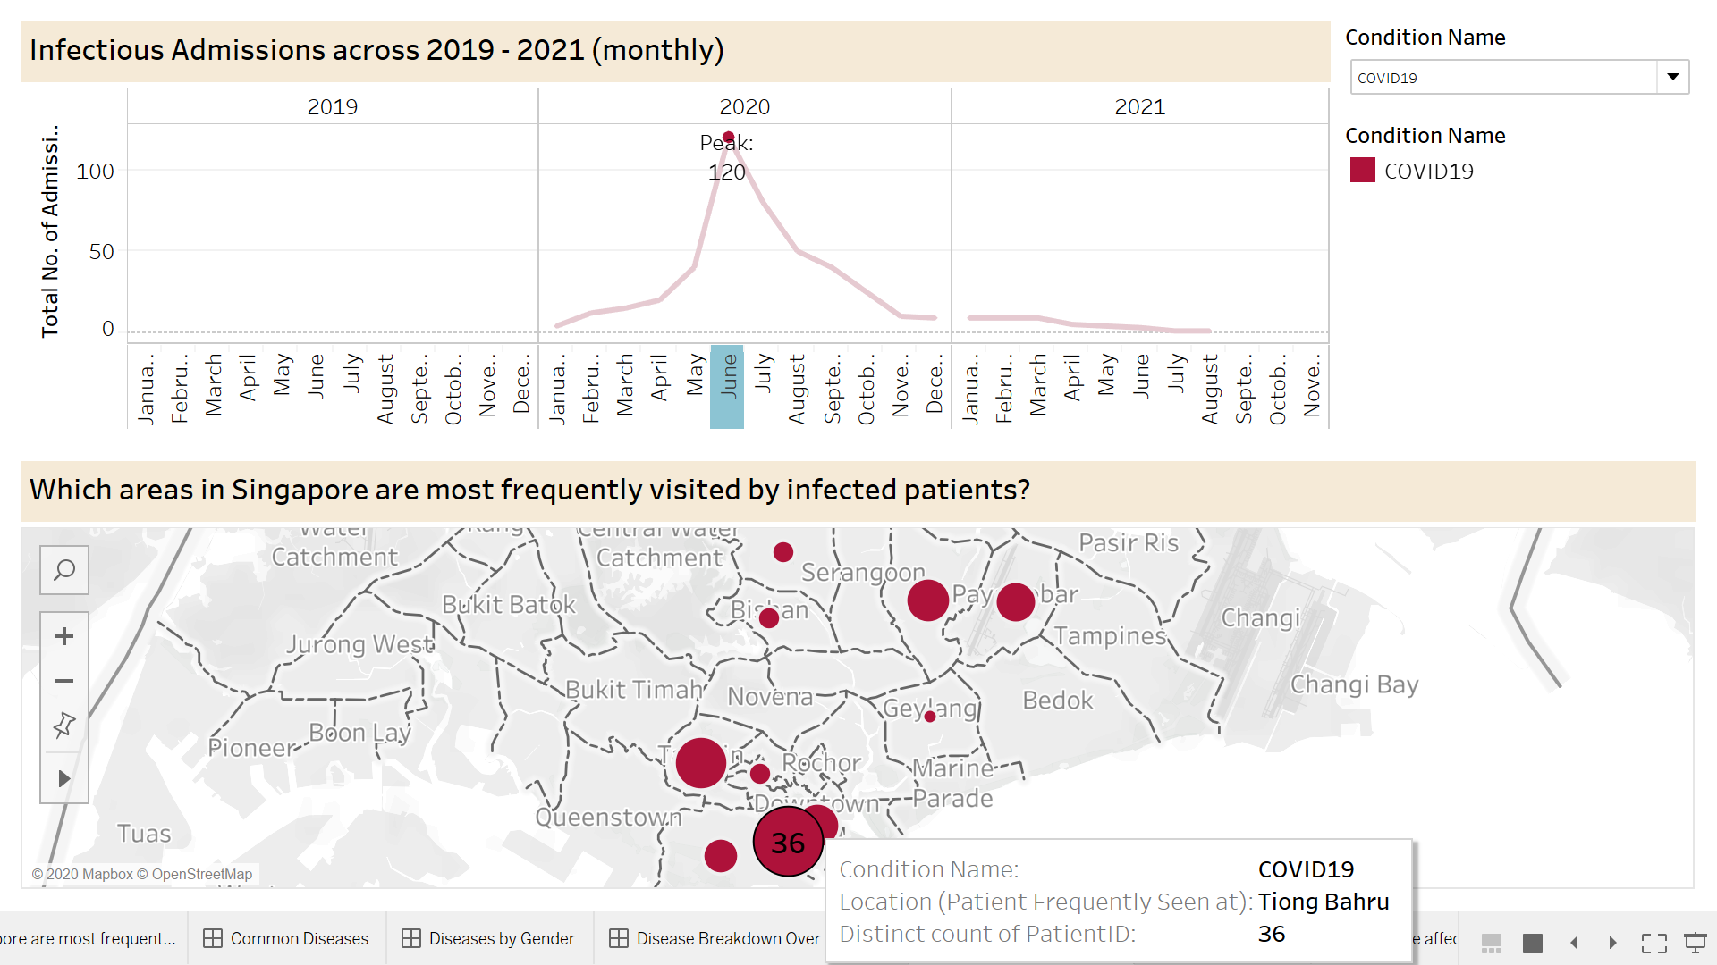

I also have a month/year feature where you can click on a particular month or a year, the graph will filter to show the data according to the filter applied. For example, if I click on the year 2020 and June filter as seen in the blue highlighted region, it only shows all the graphs related June 2020 for the line graphs and the geocoded graph. Hence it is very visible that June 2020 has the highest number of COVID-19 patients of 120. In the geo-coded graph, it showed that the Tiong Bahru region has the highest number of COVID-19 Patients. As such government, can alert the residents of Tiong Bahru to be more careful and conscious during the next months, to ensure that there is lesser spread of the virus

**Conclusion and Recommendation for dashboard** **[PRIYA]**

Using such graph insights, we would be able to predict which departments would need the highest number of accommodations and vice versa. Those we can allocate patients according to the department's demands. At the same time, we can analyse other insights like the admissions trend of COVID-19, as compared to other medical conditions, the hospital admission before (year 2019) and after the introduction of COVID-19 in Singapore. Further analysis of the Infectious Departments across 2019-2021 due to its high number of admissions in Department can also be done.

In conclusion, we can infer that in the year 2020, especially in the middle of the year, there many patients will lack bed accommodations, due to the overwhelming admissions from the COVID-19 infectious disease

However, from June 2020 onwards, we can notice that the number of COVID-19 admissions has decreased. Hence from this we can conclude that Around June 2020, COVID vaccine has been found and those more patients are recovering from COVID-19. Also, in 2021, we can see that COVID-19 has drastically dropped. As is lesser issues with regards to patients overcrowding more people have become health-conscious due to Pandemic.

On the other hand, this Geocoded graph can not only be helpful for the hospital, but for the government as well. It is because, COVID- 19 virus can be easily spread to another person, when there is contact between people. Hence both Hospital and government can use this geocoded data for contact tracing purposes, informing the general public regarding the clusters. As such the general public will be more mindful about their safety. With geocoding, we can do a swab test on the suspected and vulnerable people, to check if they have contacted COVID-19, reducing spread of COVID-19.

***iii)Finding out how patients' admissions affect the ward type commonly used in 2019-2021.*[PRIYA]**

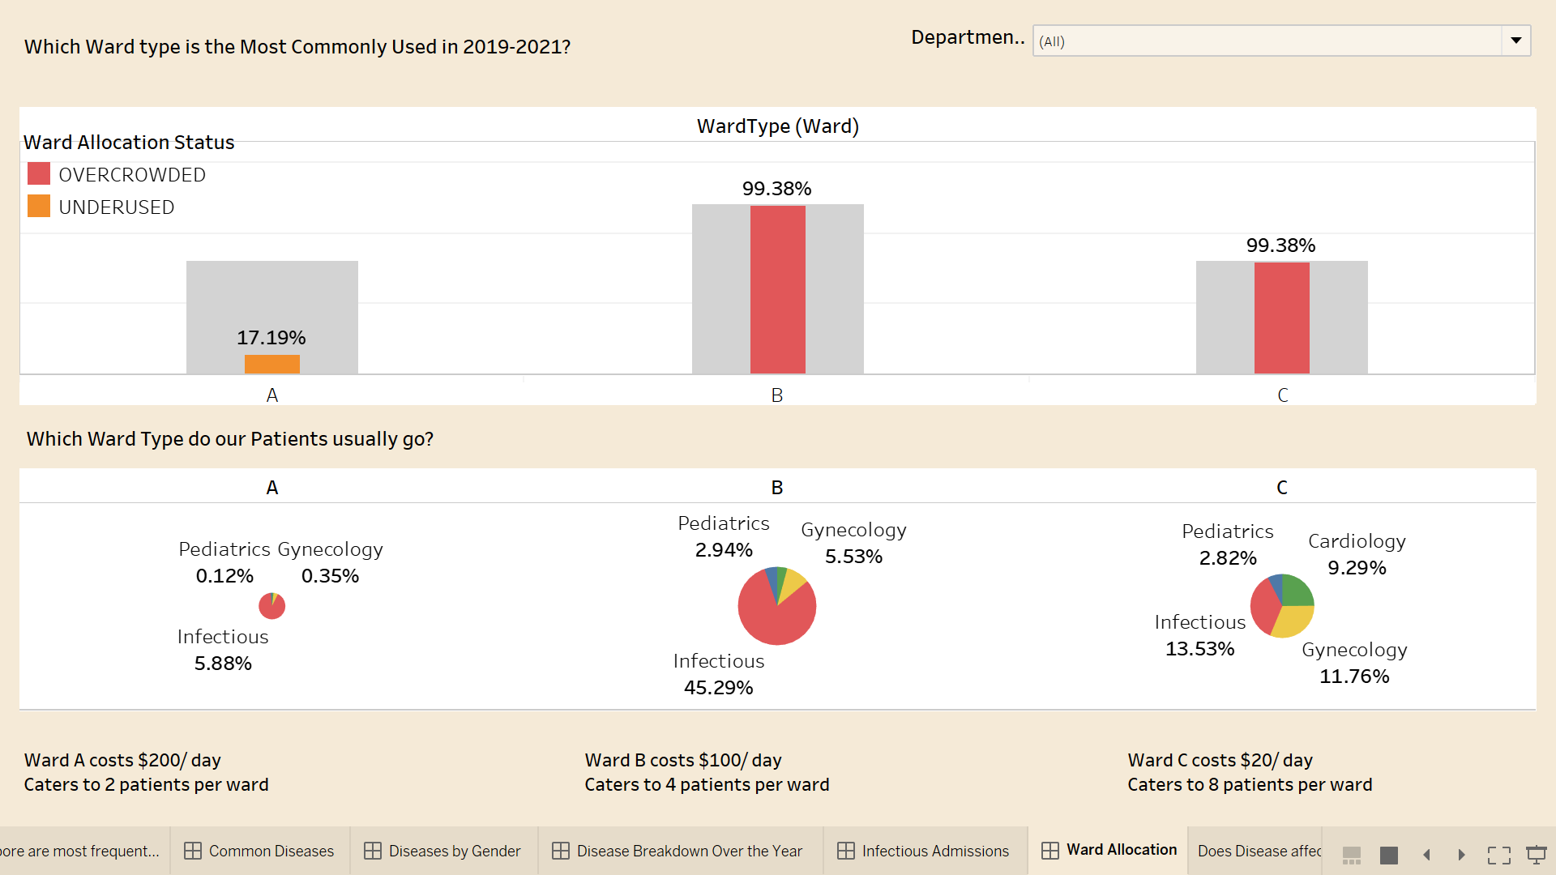

In the United Hospital Centre, there are 3 types of ward available: Type A, B, C. Below is the information about the wards type.

1. Ward Type A:

* Cost: $200 per day
* Catered 2 patients per ward at a time.
* Total of 320 wards available
* Excellent customer services/facilities
* Excellent privacy for patients available

1. Ward Type B:

* Cost: $100 per day
* Catered 4 patients per ward at a time.  
  Total of 480 wards available  
  Good customer services/facilities  
  Good privacy for patients available

1. Ward Type C:

* Cost: $20 per day
* Catered 8 patients per ward at a time.  
  480 wards available  
  Average Customer Services/Facilities  
  Average private for patients available

**Graph 1: Overlap Column relating Ward types with occupancy rate**

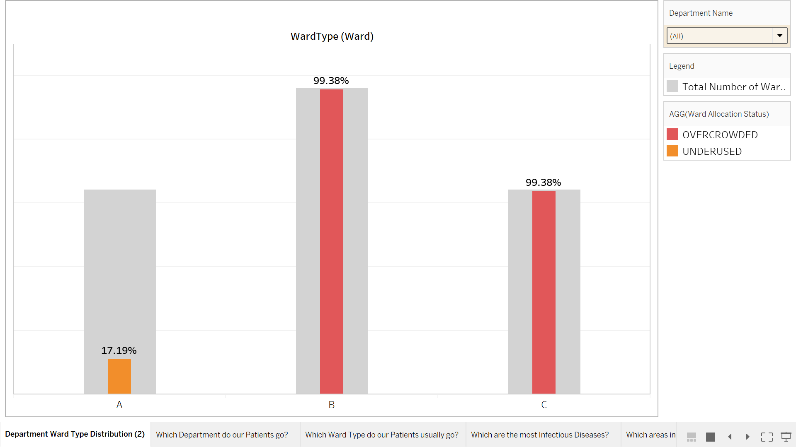  
  
The overlap column chart above is useful in comparing two related data points and especially powerful to determine if there is an important relationship between these two data points, namely ward type and occupancy rate.

By using the dual-axis bar chart, we can immediately tell ward space was wasted within one glance as indicated by the legends - Grey Bars indicate the Total Available Wards while the smaller coloured bars indicate the Total Occupied Wards.

A metric was also created for the hospital staff to easily access the ward allocation status. The percentage (%) shows how many wards were taken up with respect to the total wards available, on average every day. The Ward Allocation Status indicates a red “Overcrowded” for above 95% ward space used, an orange “Normal” for ward space used between 50% to 95% and a blue “Underused” for ward space used below 50%.

From the graph above comprising all departments, we can see that Type A wards are the most underused at a low 17.19% while Type B and C wards are at a high overcrowded rate of 99.38%.

Upon a demographic breakdown, we noticed that the reason is largely due to the fact that Type A is the most expensive and luxurious ward while Type C is the cheapest and basic ward. Despite patients admitted in the UHC coming from different age ranges, nationalities and income levels, most still prefer Type B or C wards due to their own comfort budget allocated for healthcare. We can infer from this that patients, regardless of age, income and nationality, would prefer to save on healthcare instead of spending unnecessarily (e.g. choosing a ward that provides bare minimum as opposed to luxury wards).

**Graph 2: Pie Chart of ward occupancy across department PRIYA**

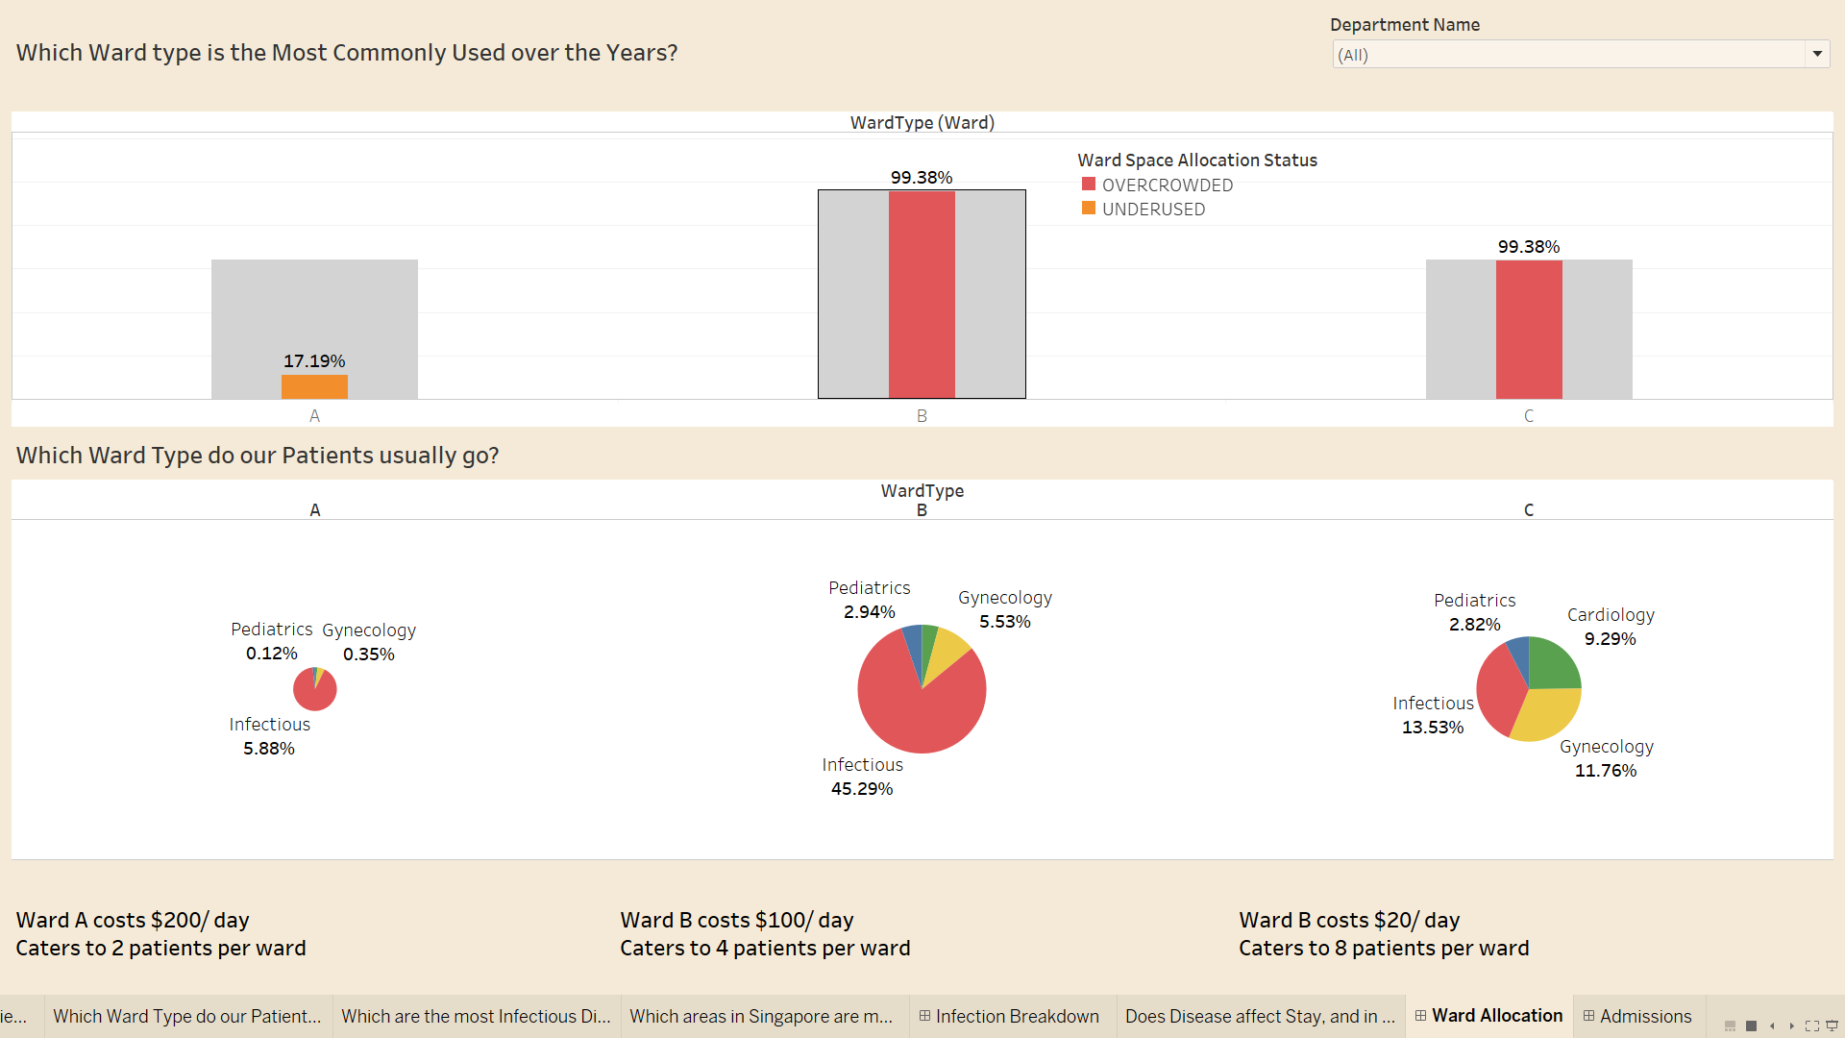  
  
The corresponding pie chart highlights that Infectious patients are largely admitted into Ward Type B at the highest ratio of 45.29%. This can potentially cause an overcrowding problem for Type B Wards.

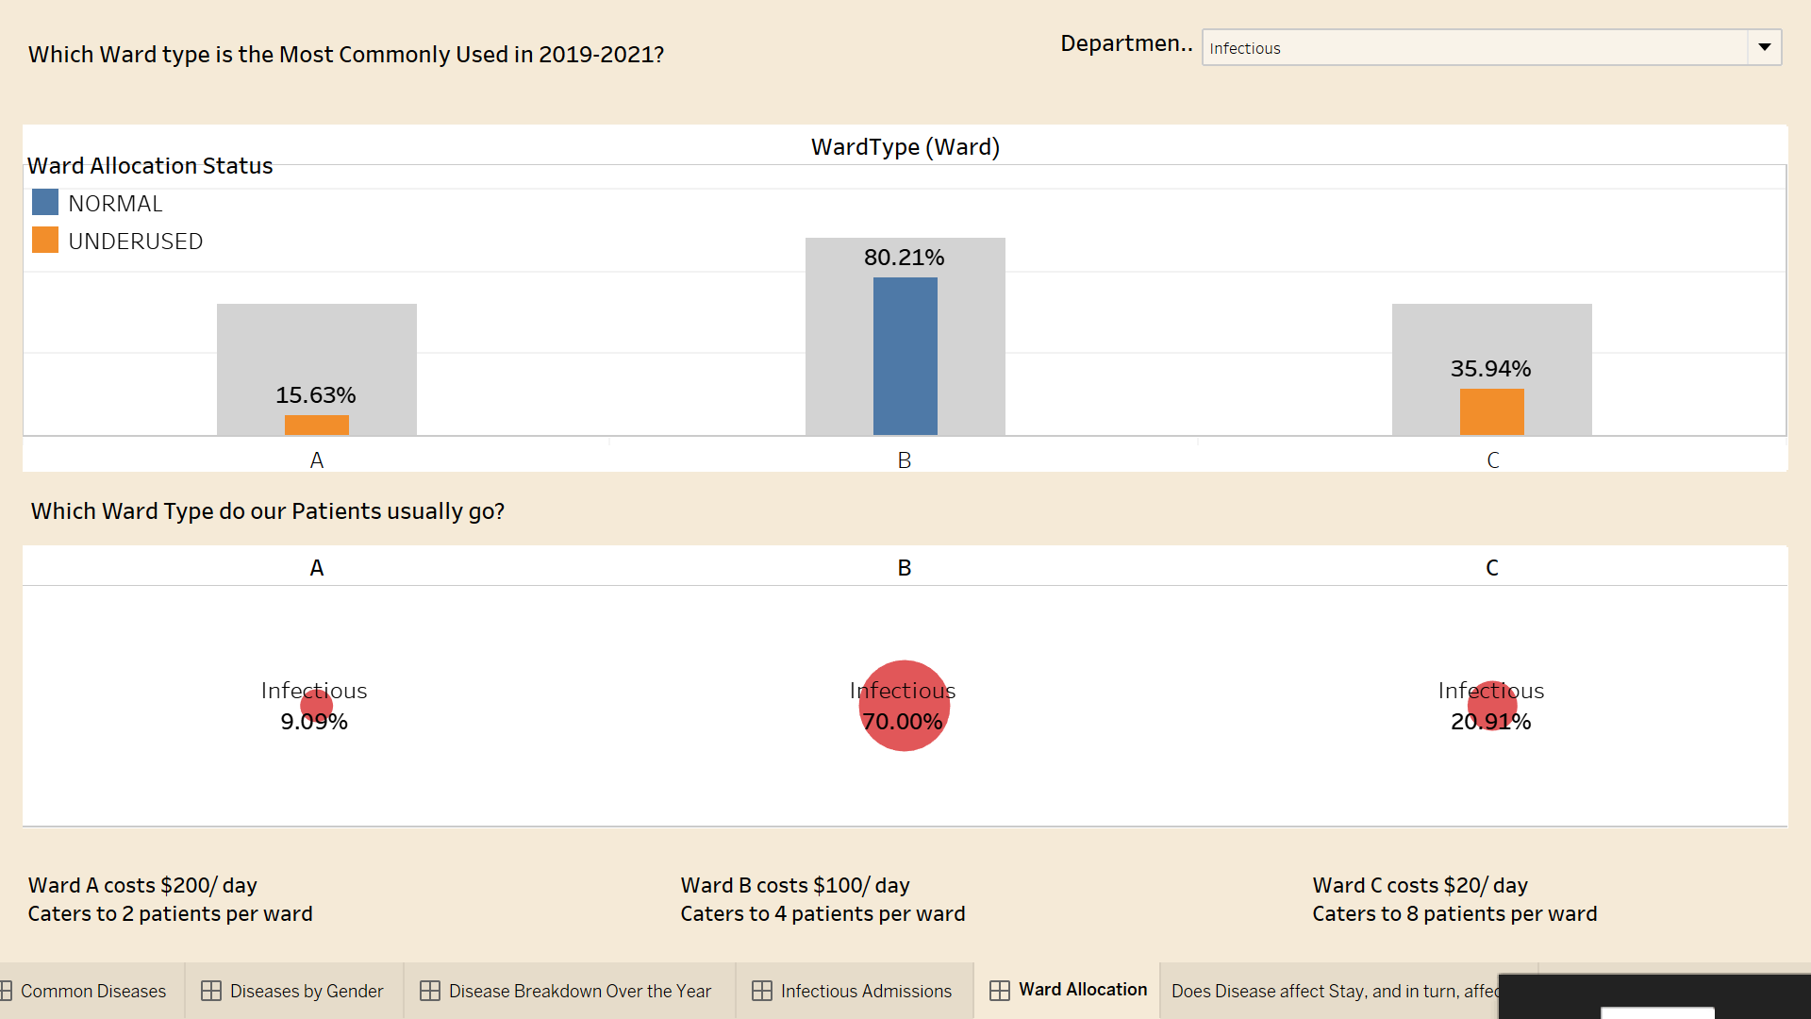

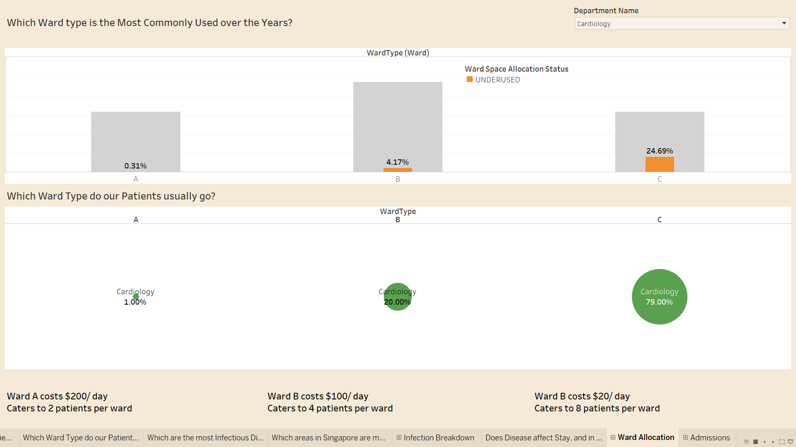

Furthermore, upon using the Department Name filter, we found out that the Infectious patients are the only highest Ward Type B occupancy at 80.21%. All other Departments and Ward types are underused. This could potentially allow us to improvise on a temporary ward space accommodation solution.

[PRIYA]

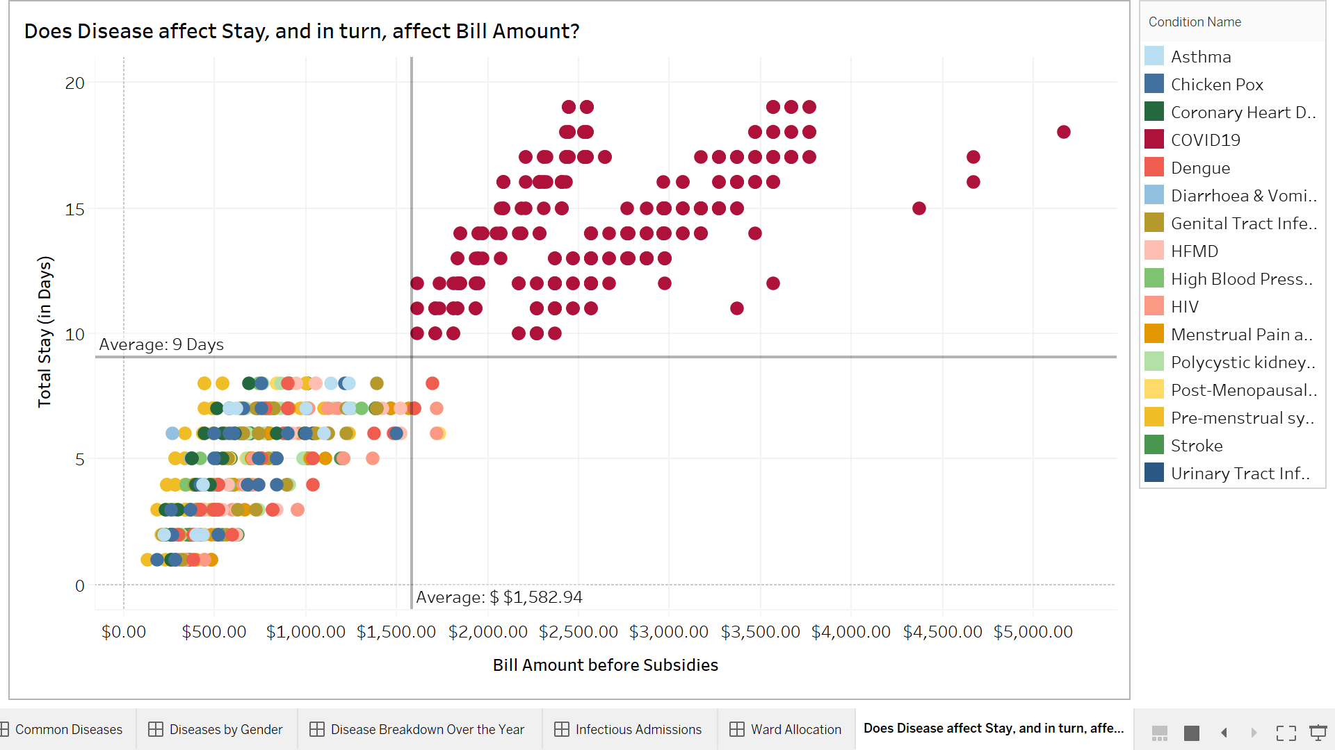  
  
The above scatterplot displays data that shows the relationship between two numerical variables - Total Stay (in Days) and Bill Amount before Subsidies with colours denoting the different medical conditions.   
  
In this scatterplot, we have included two lines comprising the averages. This visualisation now can be delved deeper by hospital member board because the medical conditions are split into four quadrants using average Total Stay and average Bill Amount before Subsidies.   
  
Medical Conditions can now be perceived into four insightful categories -   
1) Short hospitalisation with low bill amount  
2) Short hospitalisation with high bill amount  
3) Long hospitalisation with low bill amount  
4) Long hospitalisation with high bill amount  
  
With this in mind, there is a direct positive correlation between the number of stays and the bill amount for all the medical conditions.

My Learning Point/Conclusion [Priya]

In conclusion, we can conclude that over the years, COVID-19 has the highest number of patients admitted with 58 patients and it is also the most expensive treatment cost average of $99 per day. Also, we can conclude that age and gender do have an impact on the type of diseases that patients get diagnosed with. In general, the elderlies are more prone to get COVID-19 their ageing In conclusion, we can infer that in the year 2020, especially in the middle of the year, there many patients will lack bed accommodations, due to the overwhelming admissions from the COVID-19 infectious disease

However, from June 2020 onwards, we can notice that the number of COVID-19 admissions has decreased. Hence from this we can conclude that Around June 2020, COVID vaccine has been found and those more patients are recovering Also, in 2021, we can see that COVID-19 has drastically dropped as people become health-conscious due to Pandemic

In conclusion, we can conclude that most of the patients stay in Type B Ward type followed by Type C word This is due to Ward A being too expensive for a typical Singaporean. Hence during the pandemic situation, where there is a lack of bed available for all patients, hence we can temporarily transfer some of the COVID patients into other departments’s (eg: Pediatrics) Type A wards as there is a lot of space available. As such during emergency periods, we can accommodate services for every patient's recovery. And we can also infer that patients admitted for COVID-19 reasons, tend to pay higher hospital bills as they stay longer to recover from the virus.

I have also learned how to do various charts using different forms like back -to back graphs, word graphs, geocodings, line trend graphs and many others. The most challenging part of this is having to create your own data chats, hence it is hard to coordinate some of the datasets together. Even though I have faced some difficulties in creating my special feature like filtering, however with the guide of Google, Youtube , Lab practices and Tableau Software, my worries have definitely gone down. Overall a fruitful lesson to learn and loved how we use the current pandemic to base our whole project on

**[NASH]**:

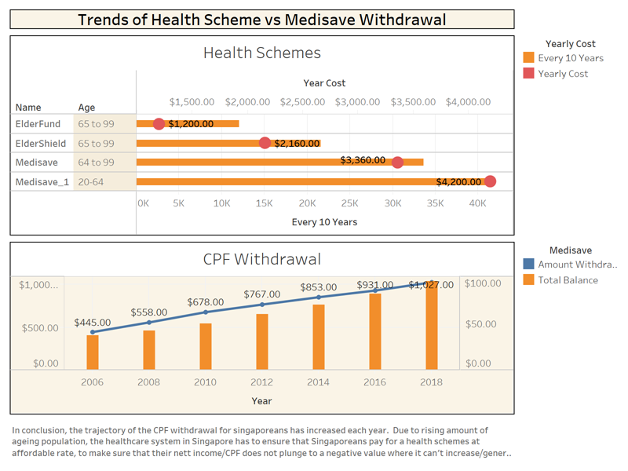

In this graph it shows a negatively high trend of the rising number on Singaporean’s withdrawing their CPF Medical uses. This is due to the rising cost of Medical Health Schemes/Subsidies Singaporeans pay for each year. If the trend continues, the remaining CPF balance of Singaporeans would be lower than the actual cost for each year to pay for the subsidies or medical bills. We would like to decrease the CPF withdrawal rate for Singaporeans by promoting a healthy lifestyle or decreasing the chances of them getting sick & admitted into hospitals.

That’s one of the key ways to also ensure that Singapore's health system cost remains stable and manageable with increase,to tackle the increasing number of Singaporeans aged 65 and above (Old-Age Population) on their CPF spending rate.

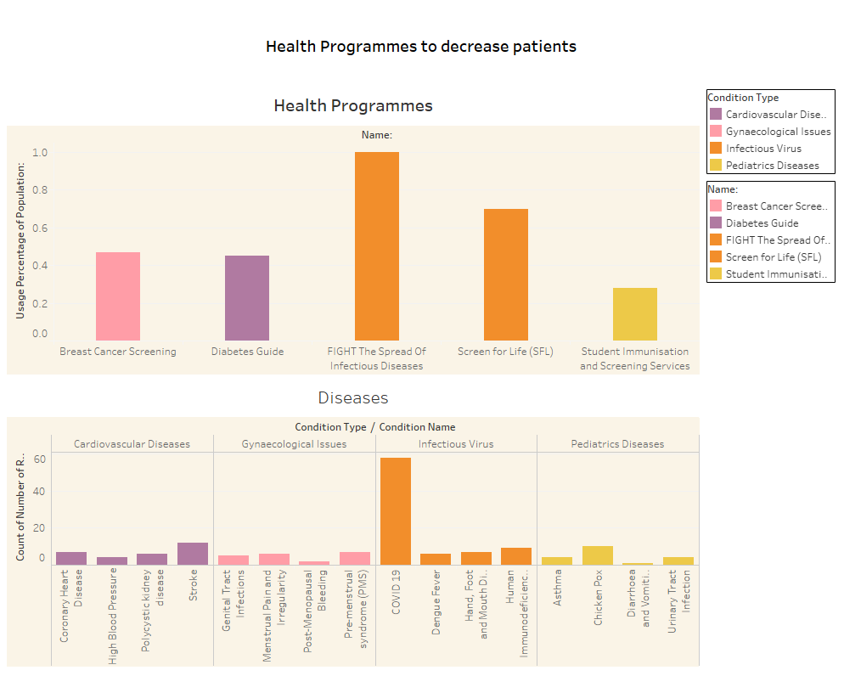

**[NASH]**

We highlighted through the graph above one of the possible ways to reduce the drastic spending of Singaporeans CPF on medical uses or schemes. Instead they could use their CPF for other means such as housing or investments. To recede the number of patients coming into our hospitals, we chose to use these Health Programmes to moderately lower their odds of getting sick. Therefore this will likely stop Singaporeans from spending their CPF or hard-earned income for medical uses.If the trend proceeds for another decade or so , our hospital can invest in introducing more diverse & specialized types of health programmes to help tackle other emerging diseases and viruses that might surface in the coming years.

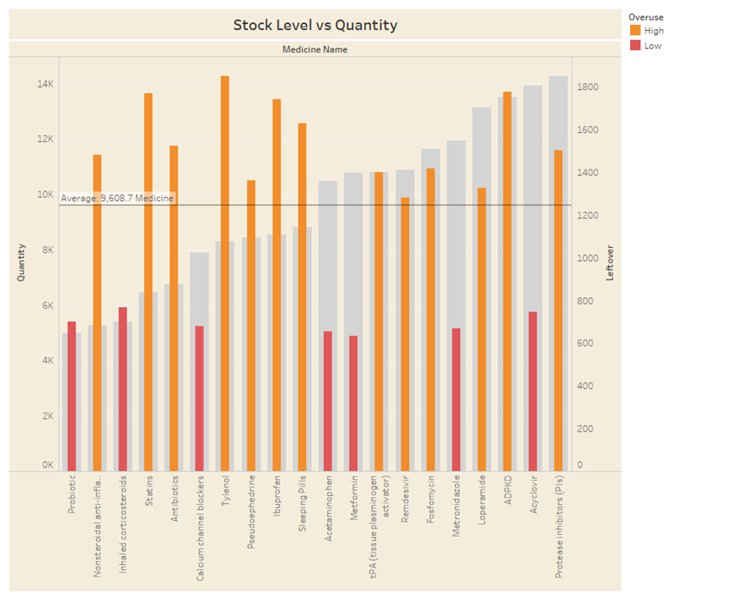

**[NASH]**

This inventory count shows the amount of medicine we sold vs how much leftover we get after each sale in a month. The overall trend of the graph shows that we have some medicine that isn't selling as well as we expected, therefore we need to allocate the inventory of medicine we have excess of to the ones that we need more. The red ones would mean that the threshold of the leftover we sold is lower than the quantity we have. Otherwise, we can use the “Orange” excess to supply the other medicines that require more stocks to meet the demands.

This could lead to us saving costs on certain types of medicine & lower the cost of healthcare in our hospital.

***Your Learning Point/ Overall Conclusion*[NASH]*:*** The main overall goal is to identify the main driver of the cost regarding the health care in Singapore. It has been identified that the main driving cost is from the medicine inventory. We can decrease the overall healthcare cost by reducing the medicine inventory based on the medicine that is only required by the basis of the disease trends.

We can also reduce this by promoting healthier lifestyles through health-programmes that can help the growing elderly-population. This would result in lower patient intake for our hospital thus would then decrease the need for medicine inventory that is costly in our hospital. Lastly, this can also help in lowering the spending of CPF for medical schemes or bills.

Tableau has helped me have an analytical approach to potentially be beneficial in the long run for our project or needs wards our daily lives through data. This has made me be more informative and insightful regarding how data can actually help us predict trends and patterns that would be useful in analyzing such data. These data can help in governmental approaches such as policies, budgets and many more attributes in a society. Which can be beneficial for everyone to make use of.

**[OWEN]**

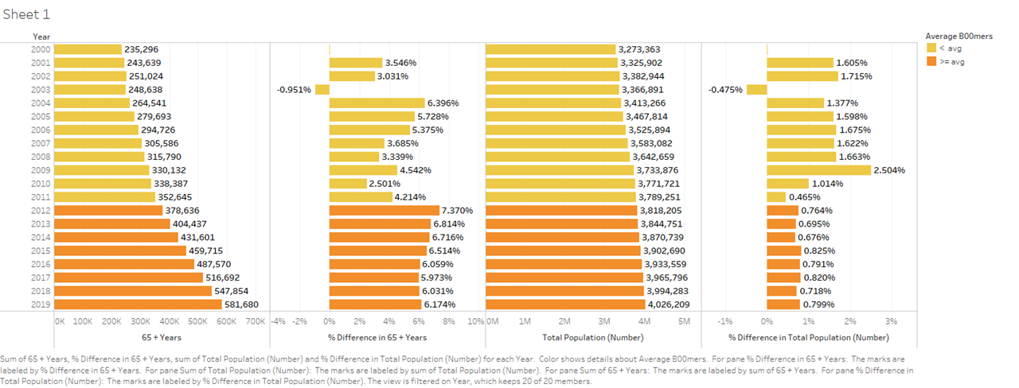

Based on research and observation , having a population demographic is very important in helping us predict population growth trends and help us figure ways to better assist the increasing elderly population.

Research has shown that Singapore’s citizen marriages and births remained stable.In 2016, there were 23,873 citizen marriages, similar to the 23,805 citizen marriages in 2017. There were 33,167 citizen births in 2016, compared with 33,725 in 2015.Singapore’s population also continues to age - about 14.4 percent of citizens were aged 65 and above, compared with 13.7 in 2016. As Singapore’s population continues to grow, it is important that we have more health schemes and programs to cater to the elderlies of our generation. Even though hospital’s revenue increases when more patients visit us, as the saying goes, “Prevention is better than Cure”, so the fewer the patients, the better!

Thus, by analyzing these population growth trends, our hospital team can roll out healthcare programs to help seniors stay healthy and offer them affordable health schemes so they won’t be forced to empty out their precious CPF savings to get treatment.

**[OWEN]**

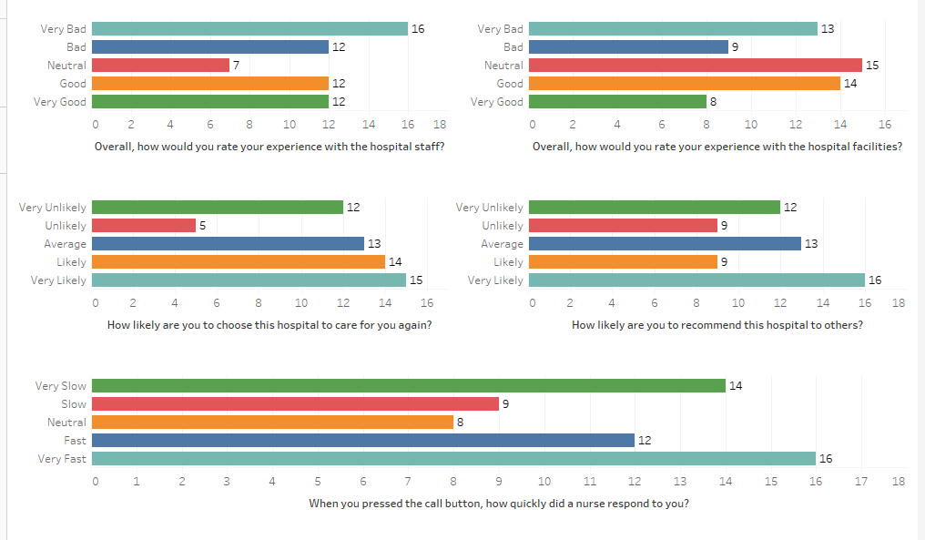

Patient Satisfaction is an important and commonly used key performance index for measuring the quality in health care. Patient satisfaction affects clinical outcomes, patient retention and medical malpractice claims. It also affects the efficient, timely and patient-focused delivery of quality healthcare.

Patient satisfaction is thus an important and effective indicator to measure the success of doctors and hospitals. Having a graph centered around the data collected from the hospital conducting surveys allows us to analyse whether patients are satisfied with our service, as well as, providing us valuable insights and feedback on how we can further improve the ambience and patient-centered service for citizens who come to our hospital to be treated.

We also get to understand what is important to our patients.The way patients are treated from the moment they enter our facility is of utmost importance.Thus,we should fully analyse and utilize this in order for us to gain the trust of citizens so that they will choose us as their go-to option should there be a need to visit a hospital.

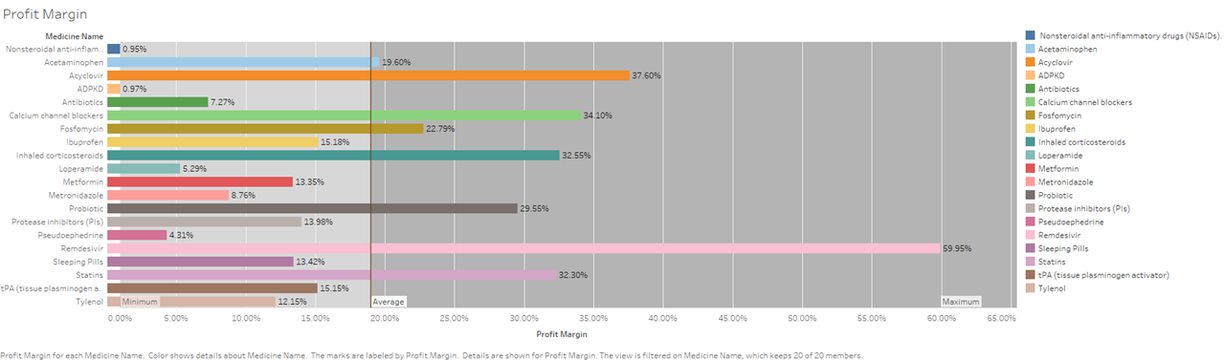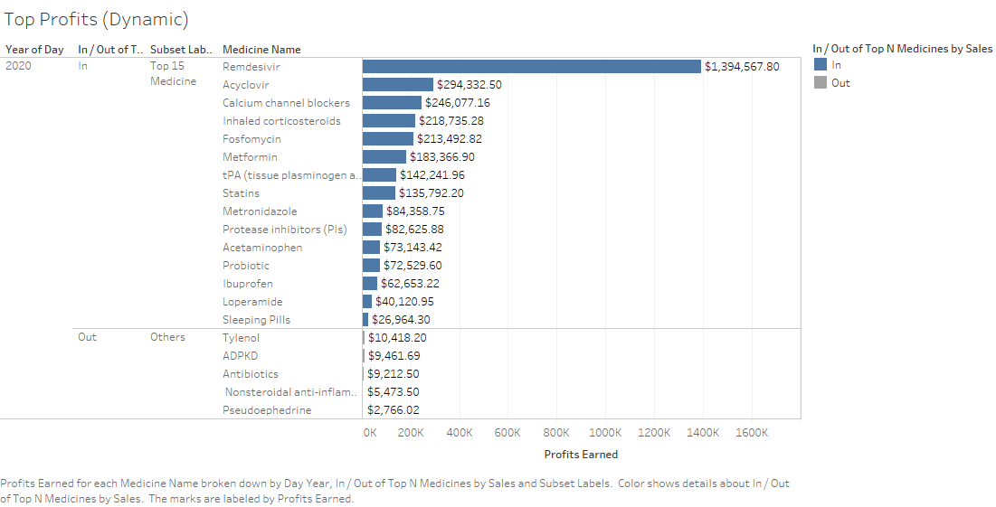

**[OWEN]**

Gross profit margin is a good measure of profitability that shows the percentage of revenue that exceeds the cost of goods sold.

The Gross Profit Margin (1st Graph) and Top Profits for each medicine(2nd graph) reflects how successful a company was in generating revenue, considering the costs involved in producing the medicine. It is a measure of the efficiency of a company in using their raw materials and labor during the production process. In short, the higher the number, the more efficient management is in generating profit for every dollar of cost involved.

By analyzing these graphs, I can conclude that a lower margin could indicate that a company is under-pricing their sales, while a higher gross profit margin indicates that a company can make a reasonable profit on sales, as long it keeps its overheads costs in check.

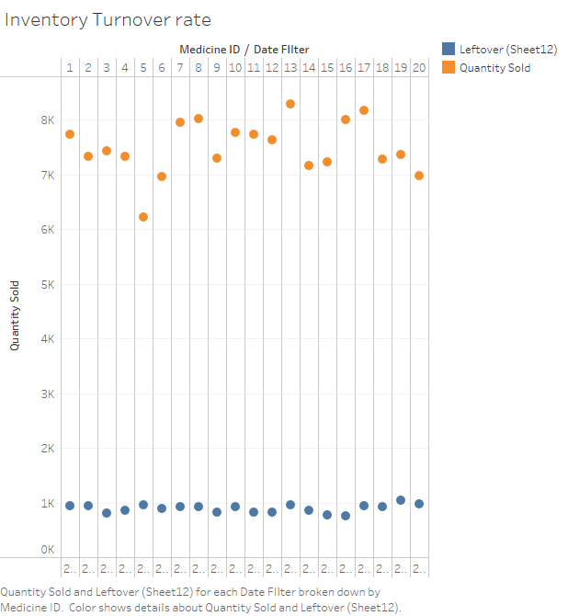

**[OWEN]**

Inventory turnover is a ratio showing how many times a company has sold and replaced inventory during a given period.Inventory turnover measures how fast a company sells inventory and how analysts compare it to industry averages.

A low turnover ratio could imply weak sales or possibly excess inventory, also known as overstocking.This indicates a problem with the medicines and other products being sold or a result of little marketing.

A high ratio implies either strong sales or insufficient inventory. The former is desirable while the latter could mean that there are multiple occasions of lost business.This leads to a high amount of cost of lost sales. However, a low inventory turnover rate is not necessarily a bad thing, such as when prices are expected to rise (inventory pre-positioned to meet fast-rising demand) or when shortages are anticipated.In conclusion, the speed at which a company can sell inventory is a critical measure of business performance.

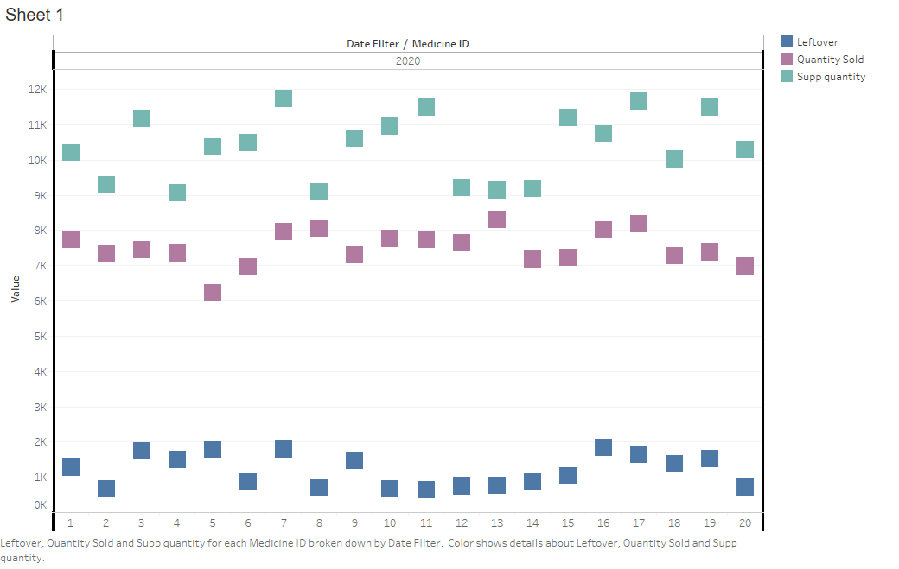

**[OWEN]**

Through this simple analysis of leftover, quantity sold , and the amount of quantity we buy on a yearly basis, it allows us to better plan the amount of medicine and goods we can order from our supplier.We can make use of this to predict how the sales trend will be like for the following weeks and months. For instance, medicine that we bought in huge quantities that did not sell too well, indicates that we could possibly reduce the amount we order while medicines that have sold close to the amount we bought, could mean that sales are doing pretty well and we can increase the quantity we order from suppliers. Certain Goods with high amounts of leftover can be carried on the next quarter, allowing us to lower the amount of orders placed so we can finish selling the leftover medicines based on FIFO.

**Overall Conclusion [OWEN]** :Firstly, due to an exponential increase in Singapore’s population each year, its is essential that we record and analyze the data, especially towards elderly to view their current and future population to allow us to better plan for their needs and develop plans that can offer them substantial healthcare while ensuring that their CPF are not being entirely used up in this sector. Secondly, sales data provides many valuable insights that our hospital can utilize to cut costs and improve product offerings. By analyzing transactions, we can spot products whose sales are under-performing overall / performing generally fine. Then, we can investigate why they are under-performing and use the patient satisfaction survey as well to refine our products offered to better meet their needs. Furthermore, the patient satisfaction surveys which have gained increasing attention as a meaningful and paramount source of information for identifying lack of patient-centered areas in our hospital and develop an effective plan for quality improvement in healthcare organizations. It also helps us work towards a better ambience and patient-centered service.

Learning points : Personally, learning tableau from scratch was great as I got to experiment and try new ways of making graphs. Being able to learn how to effectively derive insights from data and effectively communicate the information gathered on paper was a good experience. Using the Superstore Sales data set can help me get a hang of how tableau operates, come up with fresh ideas on how to make new graphs and inspire me to find out what other ways can I convey data that can pique the interests of people. Lastly, I have learnt to tell a data story and verbally explain my findings as it is a critical factor in data analysis.

**8. Overall Project Conclusion [OWEN & MITHIYRA]**

In conclusion, our report contains multiple insights and findings we have obtained with regards to a hospital called “United Hospital Center” or UHC. We have analyzed and researched the multiple issues and problems that have been commonly faced by the Singapore Healthcare System with regards to management of staff, stock levels of inventory, as well as overall disease trends based on patient intakes in our hospital.Some valuable insights and solutions that we have found out are stated below.

**Patient centered** : There were a high number of cases in January 2020 till May 2020 while in June onwards, there were fewer admissions of patients diagnosed with COVID-19. During the duration of January till May 2020, it's likely there will be fewer bed accommodations due to the overwhelming number of intakes of patients. Backed up by research, it has been shown that Type B followed by Type C wards are mostly occupied while Type A wards have been generally empty due to its high cost, especially during June 2020 period. Hence a great solution to this could be moving the patients to the other departments’ Type A wards to accommodate them, thus allowing them to have a speedy recovery.Furthermore, our research have shown and proven that gender, as well as age, have an impact on the chance of getting infected by COVID-19.

**Staff centered** : The main goal is to properly serve every patient despite the growing number of COVID-19 infectees and maximize staff efficiency. The focus of the hospital is to strategically allocate staff across the Day and Night shifts so that patients don’t get ignored no matter the time. Since the number of patients in the Infectious department is very high, staff from other departments should be shifted into the Infectious department to cater to the COVID-19 and Dengue fever infectees. To cater to incoming COVID-19 patients, converting empty type A wards to type C will be a good solution so that more people can be treated.

**Inventory and Health Schemes centered** : Our main goal is to identify the main driver of the cost regarding health care in Singapore.When we identify the cost, we can decrease it via medicine inventory. By only stocking the required amount of medicines needed, we can produce a trend model of the number of patients over the year. By minimizing inventory, we lower the overall cost spending of the hospital, and it will imminently lead to a lesser returning capital for the hospital.However , we can counter the lack of income by providing programs that educate the older and up-coming generations of Singaporeans about healthy lifestyles. This allows them to stay healthy in the long run, but also passively earns the hospital revenue, killing two birds with one stone.

**Sales and feedback centered:** The main goals are to provide proper healthcare to the elderly without it being too expensive and to better meet patients’ needs by using patients’ satisfaction surveys. It is important to analyze data surrounding the elderly to develop plans that cater to their needs, at an affordable price. Since the elderly aren’t the most well to do people, making sure their CPF isn’t entirely used is important. Through analyzing transactions, products that are under-performing or performing fine can be spotted. Connecting these trends to patients’ satisfaction surveys can give us reasons on why certain products are doing well or not.